# **CDA 6214-001: Structure VLSI Design**

**Submitted By: Saivineeth Suram (Z23704703)**

## Code generation, compilation, and schematics

We utilize Logisim simulation software to create a high-level Verilog code, and for timing simulation and verification of the generated code, we leverage Intel QuartusTM combined with ModelSimTM.

## Design diagram

Logisim is a graphical design tool that allows users to manually layout each gate and wire, converting the design into Verilog code internally. This software is widely utilized in the VLSI industry for both educational and instructional purposes.

Here's a representation of a schematic created in Logisim:

Inputs: Marked with the color "BLUE."

Outputs: Indicated by the color "RED."

Single Wires: Represented by the color "GREEN."

Busses: Displayed in the color "BLACK."  
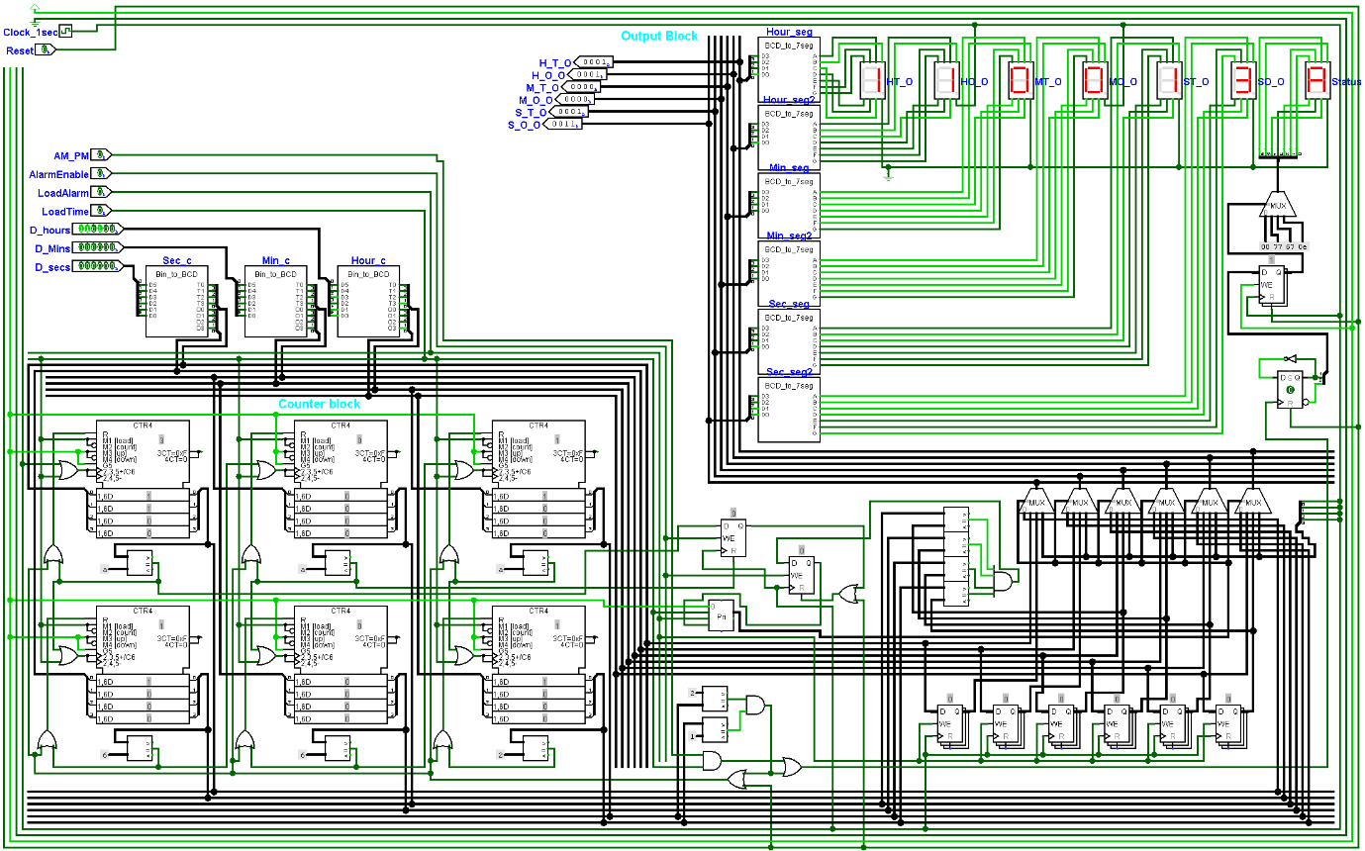

Fig 1 : Logisim design simulation with wiring counters and diagram

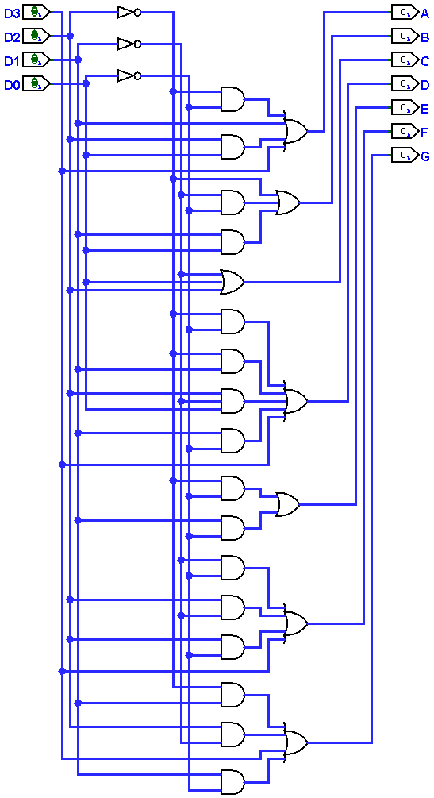  
Fig 2: BCD to 7 segment display

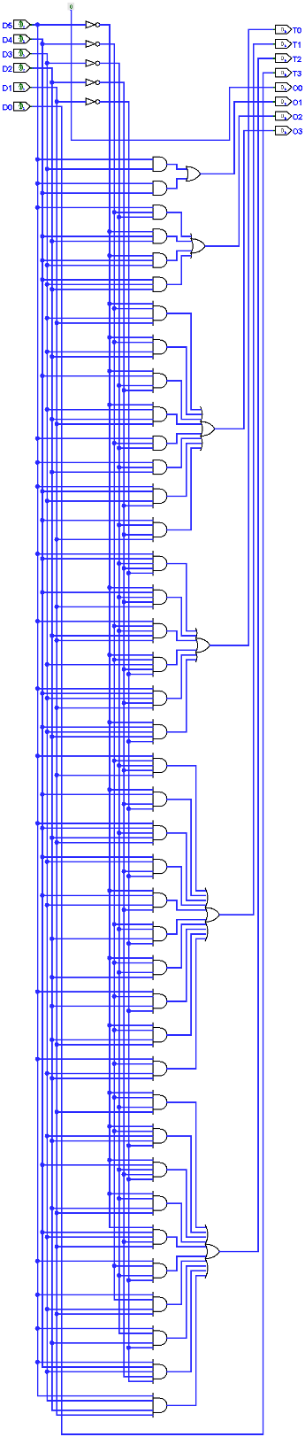  
Fig 3 : 6 bit binary to BCD

## Code Compilation and Simulation testing

The code produced by Logisim undergoes inspection, and optimizations are applied using ModelSim.

## Code compilation success

The code below has been successfully compiled and is prepared for utilization in any FPGA equipped with 7-segment displays. It includes inputs for entering, loading time, and managing alarms.

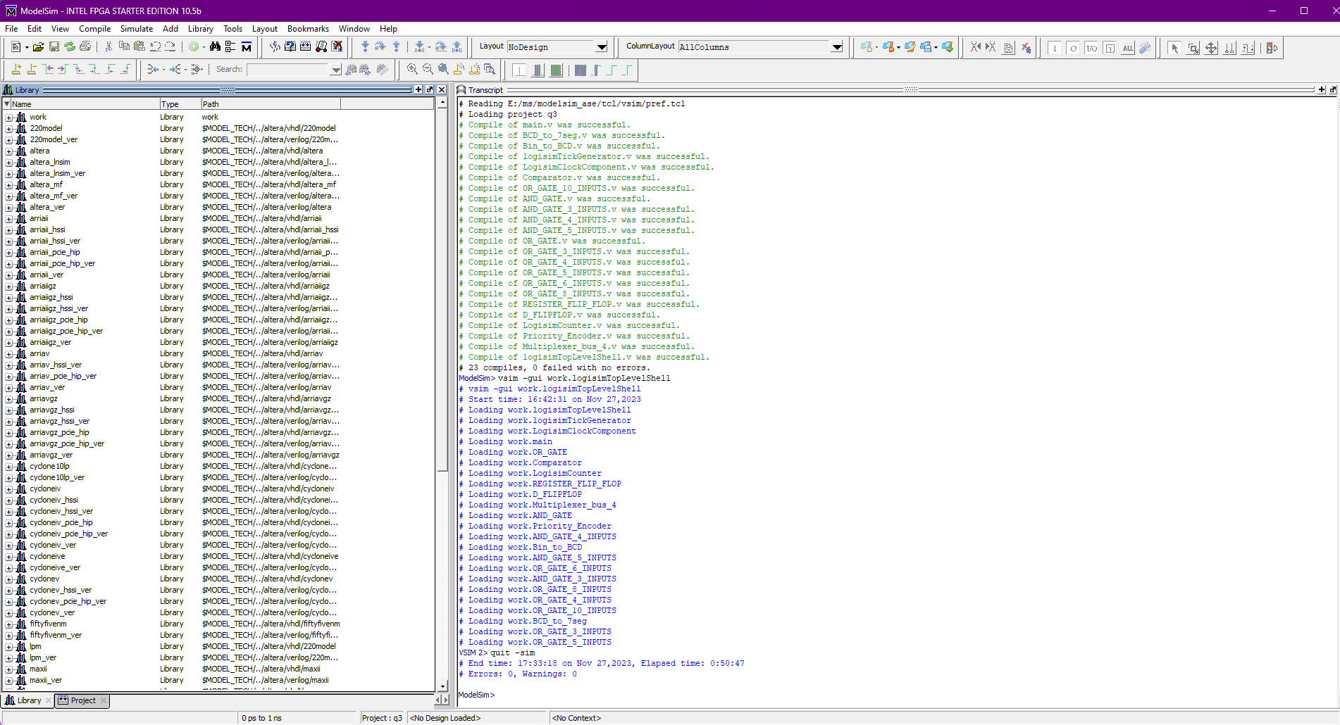

## Simulation begin success

To guarantee consistency with Logisim, we verify whether the simulation has been loaded correctly within ModelSim.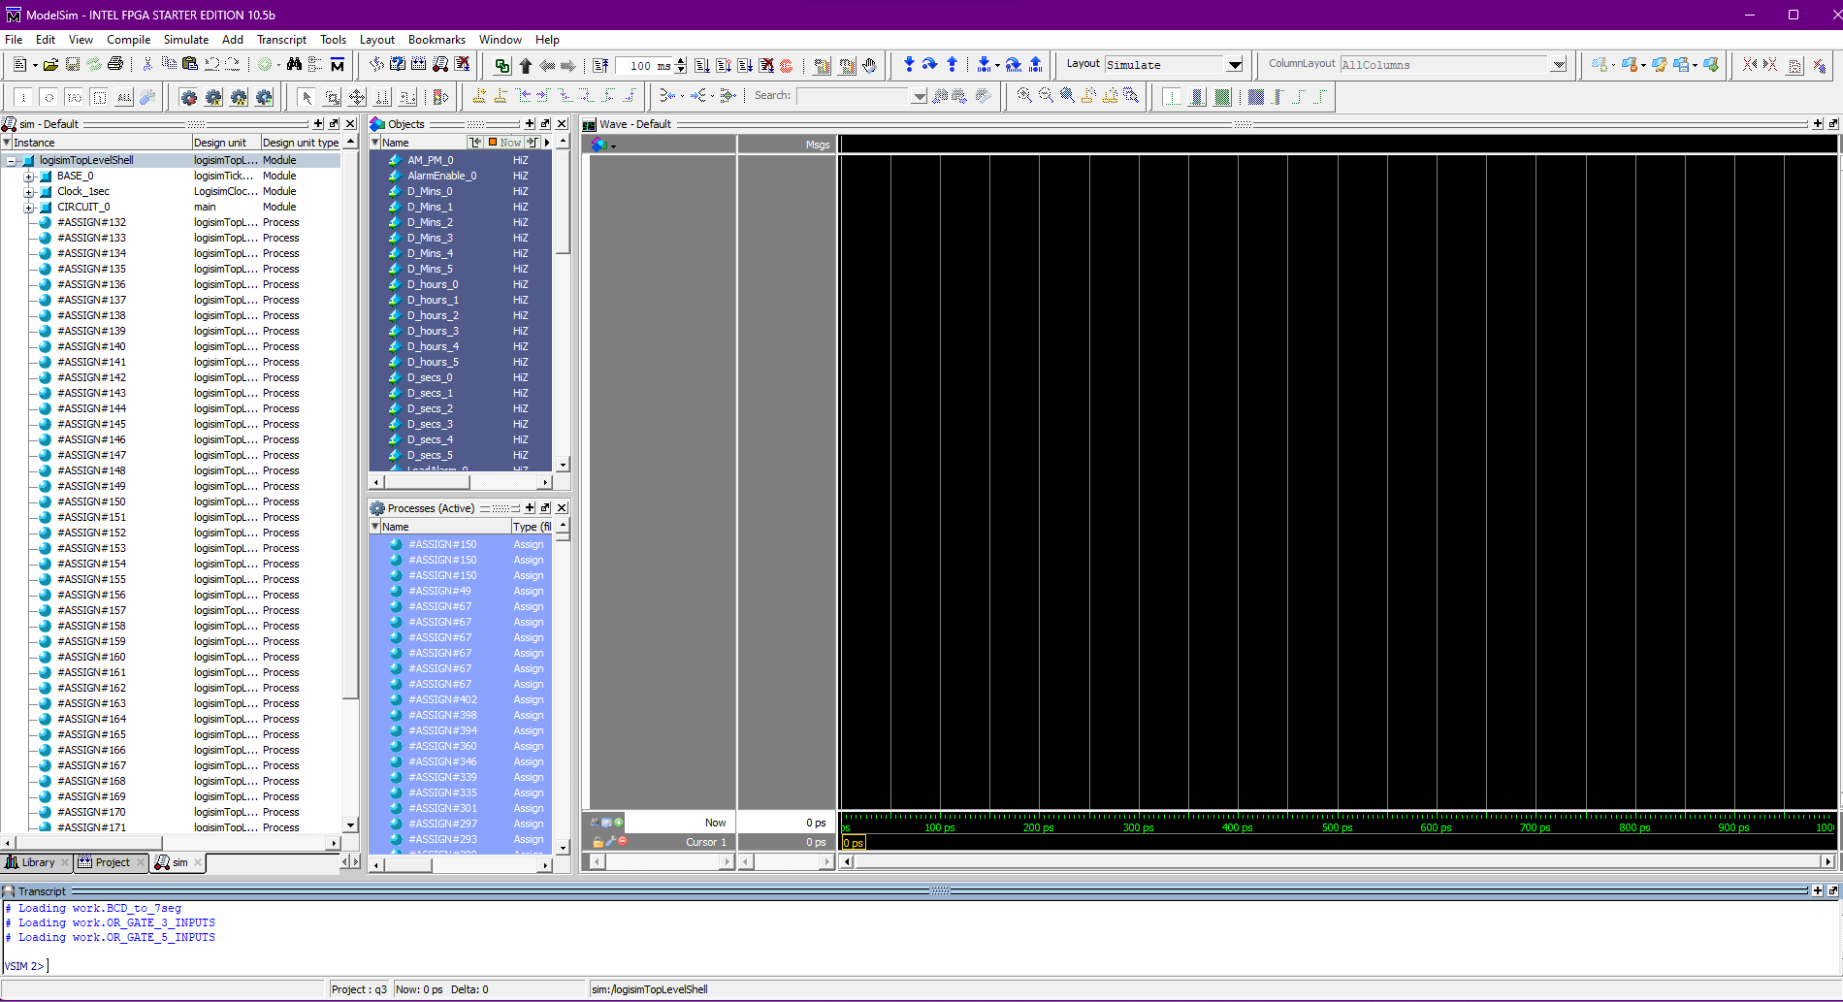

## Timing Diagram

Fig 1 : Reflecting output in modelsim for time load and alarm load

Fig 2 : Reflecting output for alarm ring

Fig 3: Reflecting diagram for loading of timeA screenshot of a computer

Description automatically generated

Fig 4 : reflecting diagram for general timing of clock ( notice fpga global clock runs faster since every global 256 clocks is 1 second clock )  
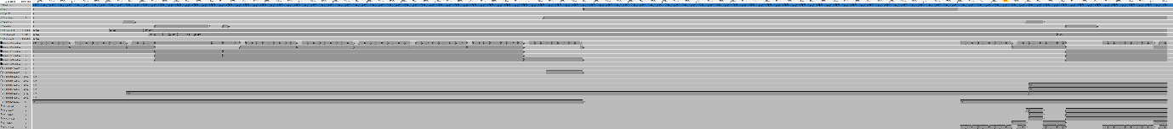

Fig 5 : Time load and alarm load on begin

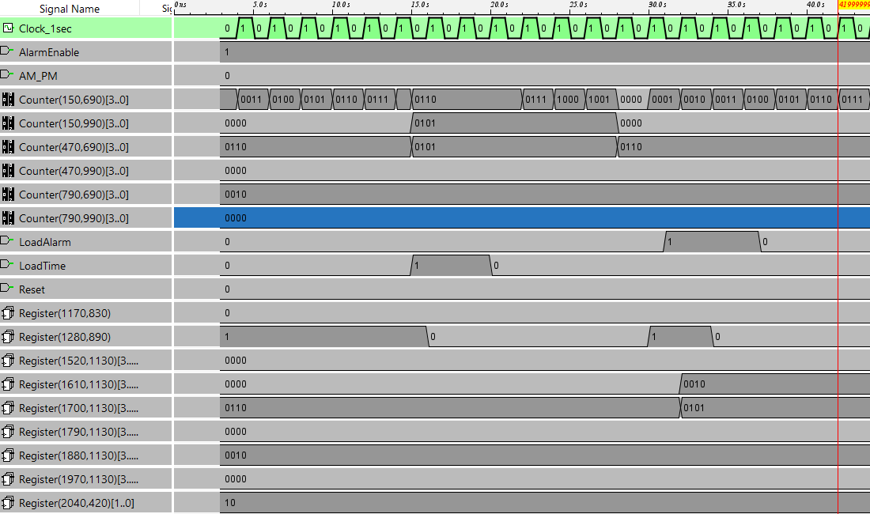

Fig 6 : Time load while running

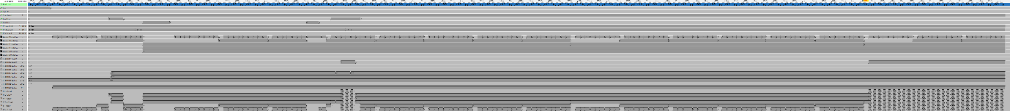

Fig 7: initial alarm to remind set time and actual alarm ring begin

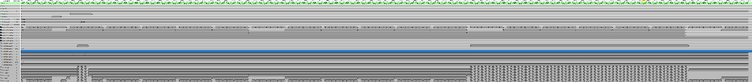

Fig 8: Alarm Ring begin and end (alarm ringing for 1 minute )

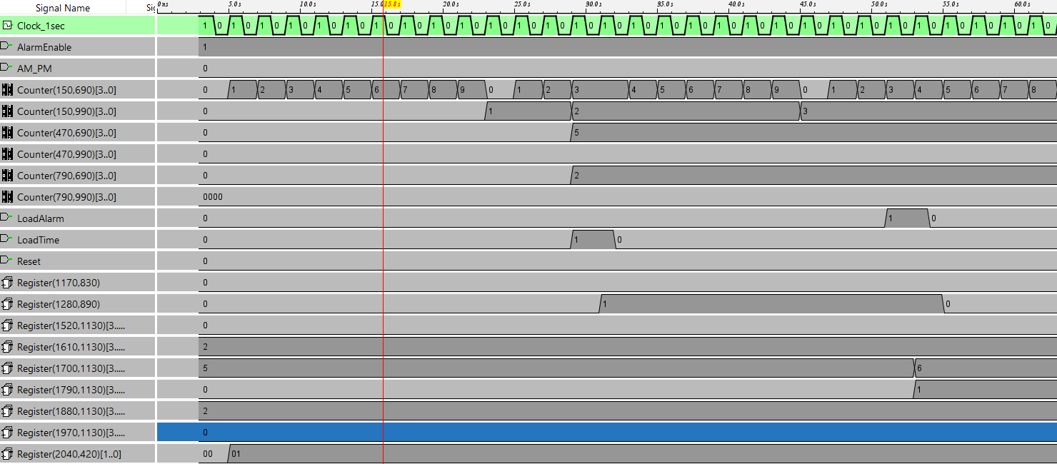

Fig 9 : Time start from zero with alarm disabled



Fig 10 : Time running and changing every 59 seconds and every 59 minutes with AM/PM toggle every 12 hours

## Code

* main.v

**module** main**(** AM_PM**,**

AlarmEnable**,**

D_Mins**,**

D_hours**,**

D_secs**,**

LoadAlarm**,**

LoadTime**,**

Reset**,**

logisimClockTree0**,**

logisimOutputBubbles **);**

** The inputs are defined here **

**input** AM_PM**;**

**input** AlarmEnable**;**

**input** **[**5**:**0**]** D_Mins**;**

**input** **[**5**:**0**]** D_hours**;**

**input** **[**5**:**0**]** D_secs**;**

**input** LoadAlarm**;**

**input** LoadTime**;**

**input** Reset**;**

**input** **[**4**:**0**]** logisimClockTree0**;**

** The outputs are defined here **

**output** **[**55**:**0**]** logisimOutputBubbles**;**

** The wires are defined here **

**wire** **[**3**:**0**]** s_logisimBus0**;**

**wire** **[**5**:**0**]** s_logisimBus106**;**

**wire** **[**1**:**0**]** s_logisimBus109**;**

**wire** **[**5**:**0**]** s_logisimBus110**;**

**wire** **[**3**:**0**]** s_logisimBus111**;**

**wire** **[**6**:**0**]** s_logisimBus116**;**

**wire** **[**6**:**0**]** s_logisimBus120**;**

**wire** **[**3**:**0**]** s_logisimBus127**;**

**wire** **[**3**:**0**]** s_logisimBus128**;**

**wire** **[**3**:**0**]** s_logisimBus129**;**

**wire** **[**6**:**0**]** s_logisimBus130**;**

**wire** **[**3**:**0**]** s_logisimBus133**;**

**wire** **[**3**:**0**]** s_logisimBus15**;**

**wire** **[**1**:**0**]** s_logisimBus17**;**

**wire** **[**3**:**0**]** s_logisimBus19**;**

**wire** **[**3**:**0**]** s_logisimBus2**;**

**wire** **[**3**:**0**]** s_logisimBus20**;**

**wire** **[**3**:**0**]** s_logisimBus23**;**

**wire** **[**3**:**0**]** s_logisimBus25**;**

**wire** **[**3**:**0**]** s_logisimBus26**;**

**wire** **[**3**:**0**]** s_logisimBus27**;**

**wire** **[**3**:**0**]** s_logisimBus32**;**

**wire** **[**3**:**0**]** s_logisimBus34**;**

**wire** **[**3**:**0**]** s_logisimBus36**;**

**wire** **[**3**:**0**]** s_logisimBus37**;**

**wire** **[**3**:**0**]** s_logisimBus4**;**

**wire** **[**5**:**0**]** s_logisimBus42**;**

**wire** **[**3**:**0**]** s_logisimBus43**;**

**wire** **[**3**:**0**]** s_logisimBus49**;**

**wire** **[**3**:**0**]** s_logisimBus51**;**

**wire** **[**3**:**0**]** s_logisimBus54**;**

**wire** **[**1**:**0**]** s_logisimBus56**;**

**wire** **[**3**:**0**]** s_logisimBus59**;**

**wire** **[**3**:**0**]** s_logisimBus6**;**

**wire** **[**6**:**0**]** s_logisimBus60**;**

**wire** **[**3**:**0**]** s_logisimBus62**;**

**wire** **[**3**:**0**]** s_logisimBus68**;**

**wire** **[**3**:**0**]** s_logisimBus79**;**

**wire** **[**3**:**0**]** s_logisimBus80**;**

**wire** **[**3**:**0**]** s_logisimBus85**;**

**wire** **[**3**:**0**]** s_logisimBus86**;**

**wire** **[**3**:**0**]** s_logisimBus89**;**

**wire** **[**3**:**0**]** s_logisimBus92**;**

**wire** **[**6**:**0**]** s_logisimBus99**;**

**wire** s_logisimNet1**;**

**wire** s_logisimNet10**;**

**wire** s_logisimNet100**;**

**wire** s_logisimNet101**;**

**wire** s_logisimNet102**;**

**wire** s_logisimNet103**;**

**wire** s_logisimNet104**;**

**wire** s_logisimNet105**;**

**wire** s_logisimNet107**;**

**wire** s_logisimNet108**;**

**wire** s_logisimNet11**;**

**wire** s_logisimNet112**;**

**wire** s_logisimNet113**;**

**wire** s_logisimNet114**;**

**wire** s_logisimNet115**;**

**wire** s_logisimNet117**;**

**wire** s_logisimNet118**;**

**wire** s_logisimNet119**;**

**wire** s_logisimNet12**;**

**wire** s_logisimNet121**;**

**wire** s_logisimNet122**;**

**wire** s_logisimNet123**;**

**wire** s_logisimNet124**;**

**wire** s_logisimNet125**;**

**wire** s_logisimNet126**;**

**wire** s_logisimNet13**;**

**wire** s_logisimNet131**;**

**wire** s_logisimNet132**;**

**wire** s_logisimNet134**;**

**wire** s_logisimNet135**;**

**wire** s_logisimNet136**;**

**wire** s_logisimNet137**;**

**wire** s_logisimNet138**;**

**wire** s_logisimNet139**;**

**wire** s_logisimNet14**;**

**wire** s_logisimNet140**;**

**wire** s_logisimNet141**;**

**wire** s_logisimNet142**;**

**wire** s_logisimNet143**;**

**wire** s_logisimNet144**;**

**wire** s_logisimNet145**;**

**wire** s_logisimNet146**;**

**wire** s_logisimNet147**;**

**wire** s_logisimNet148**;**

**wire** s_logisimNet149**;**

**wire** s_logisimNet150**;**

**wire** s_logisimNet151**;**

**wire** s_logisimNet152**;**

**wire** s_logisimNet153**;**

**wire** s_logisimNet154**;**

**wire** s_logisimNet155**;**

**wire** s_logisimNet156**;**

**wire** s_logisimNet157**;**

**wire** s_logisimNet158**;**

**wire** s_logisimNet159**;**

**wire** s_logisimNet16**;**

**wire** s_logisimNet160**;**

**wire** s_logisimNet161**;**

**wire** s_logisimNet162**;**

**wire** s_logisimNet163**;**

**wire** s_logisimNet164**;**

**wire** s_logisimNet165**;**

**wire** s_logisimNet166**;**

**wire** s_logisimNet167**;**

**wire** s_logisimNet168**;**

**wire** s_logisimNet169**;**

**wire** s_logisimNet170**;**

**wire** s_logisimNet171**;**

**wire** s_logisimNet172**;**

**wire** s_logisimNet173**;**

**wire** s_logisimNet174**;**

**wire** s_logisimNet175**;**

**wire** s_logisimNet176**;**

**wire** s_logisimNet177**;**

**wire** s_logisimNet178**;**

**wire** s_logisimNet179**;**

**wire** s_logisimNet18**;**

**wire** s_logisimNet180**;**

**wire** s_logisimNet181**;**

**wire** s_logisimNet182**;**

**wire** s_logisimNet183**;**

**wire** s_logisimNet184**;**

**wire** s_logisimNet185**;**

**wire** s_logisimNet186**;**

**wire** s_logisimNet187**;**

**wire** s_logisimNet188**;**

**wire** s_logisimNet189**;**

**wire** s_logisimNet190**;**

**wire** s_logisimNet191**;**

**wire** s_logisimNet192**;**

**wire** s_logisimNet193**;**

**wire** s_logisimNet194**;**

**wire** s_logisimNet195**;**

**wire** s_logisimNet196**;**

**wire** s_logisimNet197**;**

**wire** s_logisimNet198**;**

**wire** s_logisimNet199**;**

**wire** s_logisimNet200**;**

**wire** s_logisimNet201**;**

**wire** s_logisimNet202**;**

**wire** s_logisimNet21**;**

**wire** s_logisimNet22**;**

**wire** s_logisimNet24**;**

**wire** s_logisimNet28**;**

**wire** s_logisimNet29**;**

**wire** s_logisimNet3**;**

**wire** s_logisimNet30**;**

**wire** s_logisimNet31**;**

**wire** s_logisimNet33**;**

**wire** s_logisimNet35**;**

**wire** s_logisimNet38**;**

**wire** s_logisimNet39**;**

**wire** s_logisimNet40**;**

**wire** s_logisimNet41**;**

**wire** s_logisimNet44**;**

**wire** s_logisimNet45**;**

**wire** s_logisimNet46**;**

**wire** s_logisimNet47**;**

**wire** s_logisimNet48**;**

**wire** s_logisimNet5**;**

**wire** s_logisimNet50**;**

**wire** s_logisimNet52**;**

**wire** s_logisimNet53**;**

**wire** s_logisimNet55**;**

**wire** s_logisimNet57**;**

**wire** s_logisimNet58**;**

**wire** s_logisimNet61**;**

**wire** s_logisimNet63**;**

**wire** s_logisimNet64**;**

**wire** s_logisimNet65**;**

**wire** s_logisimNet66**;**

**wire** s_logisimNet67**;**

**wire** s_logisimNet69**;**

**wire** s_logisimNet7**;**

**wire** s_logisimNet70**;**

**wire** s_logisimNet71**;**

**wire** s_logisimNet72**;**

**wire** s_logisimNet73**;**

**wire** s_logisimNet74**;**

**wire** s_logisimNet75**;**

**wire** s_logisimNet76**;**

**wire** s_logisimNet77**;**

**wire** s_logisimNet78**;**

**wire** s_logisimNet8**;**

**wire** s_logisimNet81**;**

**wire** s_logisimNet82**;**

**wire** s_logisimNet83**;**

**wire** s_logisimNet84**;**

**wire** s_logisimNet87**;**

**wire** s_logisimNet88**;**

**wire** s_logisimNet9**;**

**wire** s_logisimNet90**;**

**wire** s_logisimNet91**;**

**wire** s_logisimNet93**;**

**wire** s_logisimNet94**;**

**wire** s_logisimNet95**;**

**wire** s_logisimNet96**;**

**wire** s_logisimNet97**;**

**wire** s_logisimNet98**;**

** The module functionality is described here **

** All clock generator connections are defined here **

**assign** s_logisimNet1 **=** logisimClockTree0**[**0**];**

** Here all wiring is defined **

**assign** s_logisimBus62**[**0**]** **=** s_logisimNet1**;**

**assign** s_logisimBus62**[**1**]** **=** s_logisimNet1**;**

**assign** s_logisimBus62**[**2**]** **=** s_logisimNet1**;**

**assign** s_logisimBus62**[**3**]** **=** s_logisimNet1**;**

** Here all input connections are defined **

**assign** s_logisimBus106**[**5**:**0**]** **=** D_secs**;**

**assign** s_logisimBus110**[**5**:**0**]** **=** D_Mins**;**

**assign** s_logisimBus42**[**5**:**0**]** **=** D_hours**;**

**assign** s_logisimNet13 **=** Reset**;**

**assign** s_logisimNet14 **=** LoadTime**;**

**assign** s_logisimNet18 **=** AlarmEnable**;**

**assign** s_logisimNet22 **=** LoadAlarm**;**

**assign** s_logisimNet57 **=** AM_PM**;**

** Here all in-lined components are defined **

// Ground

**assign** s_logisimNet28 **=** 1'b0**;**

// Power

**assign** s_logisimNet47 **=** 1'b1**;**

// Constant

**assign** s_logisimBus15**[**3**:**0**]** **=** 4'hA**;**

// Constant

**assign** s_logisimBus127**[**3**:**0**]** **=** 4'h6**;**

// Constant

**assign** s_logisimBus20**[**3**:**0**]** **=** 4'hA**;**

// Constant

**assign** s_logisimBus128**[**3**:**0**]** **=** 4'h6**;**

// Constant

**assign** s_logisimBus23**[**3**:**0**]** **=** 4'hA**;**

// Constant

**assign** s_logisimBus129**[**3**:**0**]** **=** 4'h2**;**

// 7-Segment Display: Status

**assign** logisimOutputBubbles**[**0**]** **=** s_logisimBus130**[**6**];**

**assign** logisimOutputBubbles**[**1**]** **=** s_logisimBus130**[**5**];**

**assign** logisimOutputBubbles**[**2**]** **=** s_logisimBus130**[**4**];**

**assign** logisimOutputBubbles**[**3**]** **=** s_logisimBus130**[**3**];**

**assign** logisimOutputBubbles**[**4**]** **=** s_logisimBus130**[**2**];**

**assign** logisimOutputBubbles**[**5**]** **=** s_logisimBus130**[**1**];**

**assign** logisimOutputBubbles**[**6**]** **=** s_logisimBus130**[**0**];**

**assign** logisimOutputBubbles**[**7**]** **=** s_logisimNet16**;**

// 7-Segment Display: MT_O

**assign** logisimOutputBubbles**[**10**]** **=** s_logisimNet76**;**

**assign** logisimOutputBubbles**[**11**]** **=** s_logisimNet38**;**

**assign** logisimOutputBubbles**[**12**]** **=** s_logisimNet96**;**

**assign** logisimOutputBubbles**[**13**]** **=** s_logisimNet52**;**

**assign** logisimOutputBubbles**[**14**]** **=** s_logisimNet87**;**

**assign** logisimOutputBubbles**[**15**]** **=** s_logisimNet16**;**

**assign** logisimOutputBubbles**[**8**]** **=** s_logisimNet24**;**

**assign** logisimOutputBubbles**[**9**]** **=** s_logisimNet5**;**

// 7-Segment Display: SO_O

**assign** logisimOutputBubbles**[**16**]** **=** s_logisimNet65**;**

**assign** logisimOutputBubbles**[**17**]** **=** s_logisimNet93**;**

**assign** logisimOutputBubbles**[**18**]** **=** s_logisimNet131**;**

**assign** logisimOutputBubbles**[**19**]** **=** s_logisimNet44**;**

**assign** logisimOutputBubbles**[**20**]** **=** s_logisimNet97**;**

**assign** logisimOutputBubbles**[**21**]** **=** s_logisimNet46**;**

**assign** logisimOutputBubbles**[**22**]** **=** s_logisimNet77**;**

**assign** logisimOutputBubbles**[**23**]** **=** s_logisimNet16**;**

// Constant

**assign** s_logisimBus116**[**6**:**0**]** **=** **{**3'b000**,** 4'h0**};**

// Constant

**assign** s_logisimBus99**[**6**:**0**]** **=** **{**3'b111**,** 4'h7**};**

// NOT Gate

**assign** s_logisimNet82 **=** **~**s_logisimBus109**[**1**];**

// Constant

**assign** s_logisimBus60**[**6**:**0**]** **=** **{**3'b110**,** 4'h7**};**

// 7-Segment Display: MO_O

**assign** logisimOutputBubbles**[**24**]** **=** s_logisimNet50**;**

**assign** logisimOutputBubbles**[**25**]** **=** s_logisimNet58**;**

**assign** logisimOutputBubbles**[**26**]** **=** s_logisimNet117**;**

**assign** logisimOutputBubbles**[**27**]** **=** s_logisimNet10**;**

**assign** logisimOutputBubbles**[**28**]** **=** s_logisimNet9**;**

**assign** logisimOutputBubbles**[**29**]** **=** s_logisimNet113**;**

**assign** logisimOutputBubbles**[**30**]** **=** s_logisimNet114**;**

**assign** logisimOutputBubbles**[**31**]** **=** s_logisimNet1**;**

// Constant

**assign** s_logisimBus120**[**6**:**0**]** **=** **{**3'b000**,** 4'hE**};**

// 7-Segment Display: HO_O

**assign** logisimOutputBubbles**[**32**]** **=** s_logisimNet3**;**

**assign** logisimOutputBubbles**[**33**]** **=** s_logisimNet108**;**

**assign** logisimOutputBubbles**[**34**]** **=** s_logisimNet75**;**

**assign** logisimOutputBubbles**[**35**]** **=** s_logisimNet121**;**

**assign** logisimOutputBubbles**[**36**]** **=** s_logisimNet61**;**

**assign** logisimOutputBubbles**[**37**]** **=** s_logisimNet40**;**

**assign** logisimOutputBubbles**[**38**]** **=** s_logisimNet41**;**

**assign** logisimOutputBubbles**[**39**]** **=** s_logisimNet1**;**

// 7-Segment Display: ST_O

**assign** logisimOutputBubbles**[**40**]** **=** s_logisimNet30**;**

**assign** logisimOutputBubbles**[**41**]** **=** s_logisimNet31**;**

**assign** logisimOutputBubbles**[**42**]** **=** s_logisimNet88**;**

**assign** logisimOutputBubbles**[**43**]** **=** s_logisimNet63**;**

**assign** logisimOutputBubbles**[**44**]** **=** s_logisimNet55**;**

**assign** logisimOutputBubbles**[**45**]** **=** s_logisimNet67**;**

**assign** logisimOutputBubbles**[**46**]** **=** s_logisimNet33**;**

**assign** logisimOutputBubbles**[**47**]** **=** s_logisimNet16**;**

// 7-Segment Display: HT_O

**assign** logisimOutputBubbles**[**48**]** **=** s_logisimNet132**;**

**assign** logisimOutputBubbles**[**49**]** **=** s_logisimNet95**;**

**assign** logisimOutputBubbles**[**50**]** **=** s_logisimNet48**;**

**assign** logisimOutputBubbles**[**51**]** **=** s_logisimNet112**;**

**assign** logisimOutputBubbles**[**52**]** **=** s_logisimNet7**;**

**assign** logisimOutputBubbles**[**53**]** **=** s_logisimNet8**;**

**assign** logisimOutputBubbles**[**54**]** **=** s_logisimNet72**;**

**assign** logisimOutputBubbles**[**55**]** **=** s_logisimNet16**;**

// Constant

**assign** s_logisimBus133**[**3**:**0**]** **=** 4'h2**;**

// Constant

**assign** s_logisimBus49**[**3**:**0**]** **=** 4'h1**;**

// Ground

**assign** s_logisimNet16 **=** 1'b0**;**

** Here all normal components are defined **

OR_GATE **#(.**BubblesMask**(**2'b00**))**

GATES_1 **(.**input1**(**s_logisimNet1**),**

**.**input2**(**s_logisimNet14**),**

**.**result**(**s_logisimNet135**));**

OR_GATE **#(.**BubblesMask**(**2'b00**))**

GATES_2 **(.**input1**(**s_logisimNet21**),**

**.**input2**(**s_logisimNet11**),**

**.**result**(**s_logisimNet104**));**

Comparator **#(.**nrOfBits**(**4**),**

**.**twosComplement**(**1**))**

ARITH_3 **(.**aEqualsB**(**s_logisimNet11**),**

**.**aGreaterThanB**(),**

**.**aLessThanB**(),**

**.**dataA**(**s_logisimBus4**[**3**:**0**]),**

**.**dataB**(**s_logisimBus15**[**3**:**0**]));**

LogisimCounter **#(.**invertClock**(**0**),**

**.**maxVal**(**4'hF**),**

**.**mode**(**0**),**

**.**width**(**4**))**

MEMORY_4 **(.**clear**(**s_logisimNet104**),**

**.**clock**(**s_logisimNet135**),**

**.**compareOut**(),**

**.**countValue**(**s_logisimBus4**[**3**:**0**]),**

**.**enable**(**s_logisimNet47**),**

**.**load**(**s_logisimNet14**),**

**.**loadData**(**s_logisimBus32**[**3**:**0**]),**

**.**tick**(**1'b1**),**

**.**upNotDown**(**s_logisimNet47**));**

LogisimCounter **#(.**invertClock**(**0**),**

**.**maxVal**(**4'hF**),**

**.**mode**(**0**),**

**.**width**(**4**))**

MEMORY_5 **(.**clear**(**s_logisimNet101**),**

**.**clock**(**s_logisimNet125**),**

**.**compareOut**(),**

**.**countValue**(**s_logisimBus26**[**3**:**0**]),**

**.**enable**(**s_logisimNet47**),**

**.**load**(**s_logisimNet14**),**

**.**loadData**(**s_logisimBus51**[**3**:**0**]),**

**.**tick**(**1'b1**),**

**.**upNotDown**(**s_logisimNet47**));**

OR_GATE **#(.**BubblesMask**(**2'b00**))**

GATES_6 **(.**input1**(**s_logisimNet11**),**

**.**input2**(**s_logisimNet14**),**

**.**result**(**s_logisimNet125**));**

Comparator **#(.**nrOfBits**(**4**),**

**.**twosComplement**(**1**))**

ARITH_7 **(.**aEqualsB**(**s_logisimNet69**),**

**.**aGreaterThanB**(),**

**.**aLessThanB**(),**

**.**dataA**(**s_logisimBus26**[**3**:**0**]),**

**.**dataB**(**s_logisimBus127**[**3**:**0**]));**

OR_GATE **#(.**BubblesMask**(**2'b00**))**

GATES_8 **(.**input1**(**s_logisimNet21**),**

**.**input2**(**s_logisimNet69**),**

**.**result**(**s_logisimNet101**));**

OR_GATE **#(.**BubblesMask**(**2'b00**))**

GATES_9 **(.**input1**(**s_logisimNet21**),**

**.**input2**(**s_logisimNet74**),**

**.**result**(**s_logisimNet100**));**

Comparator **#(.**nrOfBits**(**4**),**

**.**twosComplement**(**1**))**

ARITH_10 **(.**aEqualsB**(**s_logisimNet12**),**

**.**aGreaterThanB**(),**

**.**aLessThanB**(),**

**.**dataA**(**s_logisimBus34**[**3**:**0**]),**

**.**dataB**(**s_logisimBus20**[**3**:**0**]));**

OR_GATE **#(.**BubblesMask**(**2'b00**))**

GATES_11 **(.**input1**(**s_logisimNet69**),**

**.**input2**(**s_logisimNet14**),**

**.**result**(**s_logisimNet134**));**

LogisimCounter **#(.**invertClock**(**0**),**

**.**maxVal**(**4'hF**),**

**.**mode**(**0**),**

**.**width**(**4**))**

MEMORY_12 **(.**clear**(**s_logisimNet100**),**

**.**clock**(**s_logisimNet124**),**

**.**compareOut**(),**

**.**countValue**(**s_logisimBus27**[**3**:**0**]),**

**.**enable**(**s_logisimNet47**),**

**.**load**(**s_logisimNet14**),**

**.**loadData**(**s_logisimBus54**[**3**:**0**]),**

**.**tick**(**1'b1**),**

**.**upNotDown**(**s_logisimNet47**));**

LogisimCounter **#(.**invertClock**(**0**),**

**.**maxVal**(**4'hF**),**

**.**mode**(**0**),**

**.**width**(**4**))**

MEMORY_13 **(.**clear**(**s_logisimNet103**),**

**.**clock**(**s_logisimNet134**),**

**.**compareOut**(),**

**.**countValue**(**s_logisimBus34**[**3**:**0**]),**

**.**enable**(**s_logisimNet47**),**

**.**load**(**s_logisimNet14**),**

**.**loadData**(**s_logisimBus68**[**3**:**0**]),**

**.**tick**(**1'b1**),**

**.**upNotDown**(**s_logisimNet47**));**

OR_GATE **#(.**BubblesMask**(**2'b00**))**

GATES_14 **(.**input1**(**s_logisimNet12**),**

**.**input2**(**s_logisimNet14**),**

**.**result**(**s_logisimNet124**));**

Comparator **#(.**nrOfBits**(**4**),**

**.**twosComplement**(**1**))**

ARITH_15 **(.**aEqualsB**(**s_logisimNet74**),**

**.**aGreaterThanB**(),**

**.**aLessThanB**(),**

**.**dataA**(**s_logisimBus27**[**3**:**0**]),**

**.**dataB**(**s_logisimBus128**[**3**:**0**]));**

OR_GATE **#(.**BubblesMask**(**2'b00**))**

GATES_16 **(.**input1**(**s_logisimNet21**),**

**.**input2**(**s_logisimNet12**),**

**.**result**(**s_logisimNet103**));**

Comparator **#(.**nrOfBits**(**4**),**

**.**twosComplement**(**1**))**

ARITH_17 **(.**aEqualsB**(**s_logisimNet71**),**

**.**aGreaterThanB**(),**

**.**aLessThanB**(),**

**.**dataA**(**s_logisimBus25**[**3**:**0**]),**

**.**dataB**(**s_logisimBus129**[**3**:**0**]));**

OR_GATE **#(.**BubblesMask**(**2'b00**))**

GATES_18 **(.**input1**(**s_logisimNet73**),**

**.**input2**(**s_logisimNet14**),**

**.**result**(**s_logisimNet126**));**

OR_GATE **#(.**BubblesMask**(**2'b00**))**

GATES_19 **(.**input1**(**s_logisimNet21**),**

**.**input2**(**s_logisimNet73**),**

**.**result**(**s_logisimNet102**));**

LogisimCounter **#(.**invertClock**(**0**),**

**.**maxVal**(**4'hF**),**

**.**mode**(**0**),**

**.**width**(**4**))**

MEMORY_20 **(.**clear**(**s_logisimNet105**),**

**.**clock**(**s_logisimNet126**),**

**.**compareOut**(),**

**.**countValue**(**s_logisimBus25**[**3**:**0**]),**

**.**enable**(**s_logisimNet47**),**

**.**load**(**s_logisimNet14**),**

**.**loadData**(**s_logisimBus89**[**3**:**0**]),**

**.**tick**(**1'b1**),**

**.**upNotDown**(**s_logisimNet47**));**

LogisimCounter **#(.**invertClock**(**0**),**

**.**maxVal**(**4'hF**),**

**.**mode**(**0**),**

**.**width**(**4**))**

MEMORY_21 **(.**clear**(**s_logisimNet102**),**

**.**clock**(**s_logisimNet136**),**

**.**compareOut**(),**

**.**countValue**(**s_logisimBus6**[**3**:**0**]),**

**.**enable**(**s_logisimNet47**),**

**.**load**(**s_logisimNet14**),**

**.**loadData**(**s_logisimBus36**[**3**:**0**]),**

**.**tick**(**1'b1**),**

**.**upNotDown**(**s_logisimNet47**));**

OR_GATE **#(.**BubblesMask**(**2'b00**))**

GATES_22 **(.**input1**(**s_logisimNet21**),**

**.**input2**(**s_logisimNet71**),**

**.**result**(**s_logisimNet105**));**

OR_GATE **#(.**BubblesMask**(**2'b00**))**

GATES_23 **(.**input1**(**s_logisimNet74**),**

**.**input2**(**s_logisimNet14**),**

**.**result**(**s_logisimNet136**));**

Comparator **#(.**nrOfBits**(**4**),**

**.**twosComplement**(**1**))**

ARITH_24 **(.**aEqualsB**(**s_logisimNet73**),**

**.**aGreaterThanB**(),**

**.**aLessThanB**(),**

**.**dataA**(**s_logisimBus6**[**3**:**0**]),**

**.**dataB**(**s_logisimBus23**[**3**:**0**]));**

REGISTER_FLIP_FLOP **#(.**invertClock**(**0**),**

**.**nrOfBits**(**2**))**

MEMORY_25 **(.**clock**(**logisimClockTree0**[**4**]),**

**.**clockEnable**(**s_logisimNet47**),**

**.**d**(**s_logisimBus109**[**1**:**0**]),**

**.**q**(**s_logisimBus56**[**1**:**0**]),**

**.**reset**(**s_logisimNet13**),**

**.**tick**(**logisimClockTree0**[**2**]));**

D_FLIPFLOP **#(.**invertClockEnable**(**0**))**

MEMORY_26 **(.**clock**(**s_logisimNet64**),**

**.**d**(**s_logisimNet82**),**

**.**preset**(**1'b0**),**

**.**q**(**s_logisimBus109**[**1**]),**

**.**qBar**(**s_logisimBus109**[**0**]),**

**.**reset**(**s_logisimNet13**),**

**.**tick**(**1'b1**));**

Multiplexer_bus_4 **#(.**nrOfBits**(**7**))**

PLEXERS_27 **(.**enable**(**1'b1**),**

**.**muxIn_0**(**s_logisimBus116**[**6**:**0**]),**

**.**muxIn_1**(**s_logisimBus99**[**6**:**0**]),**

**.**muxIn_2**(**s_logisimBus60**[**6**:**0**]),**

**.**muxIn_3**(**s_logisimBus120**[**6**:**0**]),**

**.**muxOut**(**s_logisimBus130**[**6**:**0**]),**

**.**sel**(**s_logisimBus56**[**1**:**0**]));**

AND_GATE **#(.**BubblesMask**(**2'b00**))**

GATES_28 **(.**input1**(**s_logisimNet123**),**

**.**input2**(**s_logisimNet91**),**

**.**result**(**s_logisimNet90**));**

Comparator **#(.**nrOfBits**(**4**),**

**.**twosComplement**(**1**))**

ARITH_29 **(.**aEqualsB**(**s_logisimNet91**),**

**.**aGreaterThanB**(),**

**.**aLessThanB**(),**

**.**dataA**(**s_logisimBus25**[**3**:**0**]),**

**.**dataB**(**s_logisimBus49**[**3**:**0**]));**

Comparator **#(.**nrOfBits**(**4**),**

**.**twosComplement**(**1**))**

ARITH_30 **(.**aEqualsB**(**s_logisimNet123**),**

**.**aGreaterThanB**(),**

**.**aLessThanB**(),**

**.**dataA**(**s_logisimBus133**[**3**:**0**]),**

**.**dataB**(**s_logisimBus6**[**3**:**0**]));**

AND_GATE **#(.**BubblesMask**(**2'b00**))**

GATES_31 **(.**input1**(**s_logisimNet57**),**

**.**input2**(**s_logisimNet14**),**

**.**result**(**s_logisimNet115**));**

OR_GATE **#(.**BubblesMask**(**2'b00**))**

GATES_32 **(.**input1**(**s_logisimNet90**),**

**.**input2**(**s_logisimNet13**),**

**.**result**(**s_logisimNet21**));**

OR_GATE **#(.**BubblesMask**(**2'b00**))**

GATES_33 **(.**input1**(**s_logisimNet115**),**

**.**input2**(**s_logisimNet90**),**

**.**result**(**s_logisimNet64**));**

Multiplexer_bus_4 **#(.**nrOfBits**(**4**))**

PLEXERS_34 **(.**enable**(**1'b1**),**

**.**muxIn_0**(**s_logisimBus6**[**3**:**0**]),**

**.**muxIn_1**(**s_logisimBus36**[**3**:**0**]),**

**.**muxIn_2**(**s_logisimBus59**[**3**:**0**]),**

**.**muxIn_3**(**s_logisimBus62**[**3**:**0**]),**

**.**muxOut**(**s_logisimBus111**[**3**:**0**]),**

**.**sel**(**s_logisimBus17**[**1**:**0**]));**

Multiplexer_bus_4 **#(.**nrOfBits**(**4**))**

PLEXERS_35 **(.**enable**(**1'b1**),**

**.**muxIn_0**(**s_logisimBus25**[**3**:**0**]),**

**.**muxIn_1**(**s_logisimBus89**[**3**:**0**]),**

**.**muxIn_2**(**s_logisimBus85**[**3**:**0**]),**

**.**muxIn_3**(**s_logisimBus62**[**3**:**0**]),**

**.**muxOut**(**s_logisimBus92**[**3**:**0**]),**

**.**sel**(**s_logisimBus17**[**1**:**0**]));**

Multiplexer_bus_4 **#(.**nrOfBits**(**4**))**

PLEXERS_36 **(.**enable**(**1'b1**),**

**.**muxIn_0**(**s_logisimBus34**[**3**:**0**]),**

**.**muxIn_1**(**s_logisimBus68**[**3**:**0**]),**

**.**muxIn_2**(**s_logisimBus2**[**3**:**0**]),**

**.**muxIn_3**(**s_logisimBus62**[**3**:**0**]),**

**.**muxOut**(**s_logisimBus43**[**3**:**0**]),**

**.**sel**(**s_logisimBus17**[**1**:**0**]));**

Multiplexer_bus_4 **#(.**nrOfBits**(**4**))**

PLEXERS_37 **(.**enable**(**1'b1**),**

**.**muxIn_0**(**s_logisimBus26**[**3**:**0**]),**

**.**muxIn_1**(**s_logisimBus51**[**3**:**0**]),**

**.**muxIn_2**(**s_logisimBus80**[**3**:**0**]),**

**.**muxIn_3**(**s_logisimBus62**[**3**:**0**]),**

**.**muxOut**(**s_logisimBus37**[**3**:**0**]),**

**.**sel**(**s_logisimBus17**[**1**:**0**]));**

Multiplexer_bus_4 **#(.**nrOfBits**(**4**))**

PLEXERS_38 **(.**enable**(**1'b1**),**

**.**muxIn_0**(**s_logisimBus27**[**3**:**0**]),**

**.**muxIn_1**(**s_logisimBus54**[**3**:**0**]),**

**.**muxIn_2**(**s_logisimBus79**[**3**:**0**]),**

**.**muxIn_3**(**s_logisimBus62**[**3**:**0**]),**

**.**muxOut**(**s_logisimBus19**[**3**:**0**]),**

**.**sel**(**s_logisimBus17**[**1**:**0**]));**

Multiplexer_bus_4 **#(.**nrOfBits**(**4**))**

PLEXERS_39 **(.**enable**(**1'b1**),**

**.**muxIn_0**(**s_logisimBus4**[**3**:**0**]),**

**.**muxIn_1**(**s_logisimBus32**[**3**:**0**]),**

**.**muxIn_2**(**s_logisimBus0**[**3**:**0**]),**

**.**muxIn_3**(**s_logisimBus62**[**3**:**0**]),**

**.**muxOut**(**s_logisimBus86**[**3**:**0**]),**

**.**sel**(**s_logisimBus17**[**1**:**0**]));**

REGISTER_FLIP_FLOP **#(.**invertClock**(**0**),**

**.**nrOfBits**(**4**))**

MEMORY_40 **(.**clock**(**logisimClockTree0**[**4**]),**

**.**clockEnable**(**s_logisimNet22**),**

**.**d**(**s_logisimBus54**[**3**:**0**]),**

**.**q**(**s_logisimBus79**[**3**:**0**]),**

**.**reset**(**1'b0**),**

**.**tick**(**logisimClockTree0**[**2**]));**

REGISTER_FLIP_FLOP **#(.**invertClock**(**0**),**

**.**nrOfBits**(**4**))**

MEMORY_41 **(.**clock**(**logisimClockTree0**[**4**]),**

**.**clockEnable**(**s_logisimNet22**),**

**.**d**(**s_logisimBus68**[**3**:**0**]),**

**.**q**(**s_logisimBus2**[**3**:**0**]),**

**.**reset**(**1'b0**),**

**.**tick**(**logisimClockTree0**[**2**]));**

REGISTER_FLIP_FLOP **#(.**invertClock**(**0**),**

**.**nrOfBits**(**4**))**

MEMORY_42 **(.**clock**(**logisimClockTree0**[**4**]),**

**.**clockEnable**(**s_logisimNet22**),**

**.**d**(**s_logisimBus36**[**3**:**0**]),**

**.**q**(**s_logisimBus59**[**3**:**0**]),**

**.**reset**(**1'b0**),**

**.**tick**(**logisimClockTree0**[**2**]));**

REGISTER_FLIP_FLOP **#(.**invertClock**(**0**),**

**.**nrOfBits**(**4**))**

MEMORY_43 **(.**clock**(**logisimClockTree0**[**4**]),**

**.**clockEnable**(**s_logisimNet22**),**

**.**d**(**s_logisimBus89**[**3**:**0**]),**

**.**q**(**s_logisimBus85**[**3**:**0**]),**

**.**reset**(**1'b0**),**

**.**tick**(**logisimClockTree0**[**2**]));**

priority_encoder PLEXERS_44 **(.**A0**(**s_logisimBus17**[**0**]),**

**.**A1**(**s_logisimBus17**[**1**]),**

**.**Y0**(**s_logisimNet47**),.**Y1**(**s_logisimNet14**),.**Y2**(**s_logisimNet22**),.**Y3**(**s_logisimNet29**));**

REGISTER_FLIP_FLOP **#(.**invertClock**(**0**),**

**.**nrOfBits**(**4**))**

MEMORY_45 **(.**clock**(**logisimClockTree0**[**4**]),**

**.**clockEnable**(**s_logisimNet22**),**

**.**d**(**s_logisimBus51**[**3**:**0**]),**

**.**q**(**s_logisimBus80**[**3**:**0**]),**

**.**reset**(**1'b0**),**

**.**tick**(**logisimClockTree0**[**2**]));**

REGISTER_FLIP_FLOP **#(.**invertClock**(**0**),**

**.**nrOfBits**(**4**))**

MEMORY_46 **(.**clock**(**logisimClockTree0**[**4**]),**

**.**clockEnable**(**s_logisimNet22**),**

**.**d**(**s_logisimBus32**[**3**:**0**]),**

**.**q**(**s_logisimBus0**[**3**:**0**]),**

**.**reset**(**1'b0**),**

**.**tick**(**logisimClockTree0**[**2**]));**

Comparator **#(.**nrOfBits**(**4**),**

**.**twosComplement**(**1**))**

ARITH_47 **(.**aEqualsB**(**s_logisimNet45**),**

**.**aGreaterThanB**(),**

**.**aLessThanB**(),**

**.**dataA**(**s_logisimBus25**[**3**:**0**]),**

**.**dataB**(**s_logisimBus85**[**3**:**0**]));**

Comparator **#(.**nrOfBits**(**4**),**

**.**twosComplement**(**1**))**

ARITH_48 **(.**aEqualsB**(**s_logisimNet122**),**

**.**aGreaterThanB**(),**

**.**aLessThanB**(),**

**.**dataA**(**s_logisimBus6**[**3**:**0**]),**

**.**dataB**(**s_logisimBus59**[**3**:**0**]));**

Comparator **#(.**nrOfBits**(**4**),**

**.**twosComplement**(**1**))**

ARITH_49 **(.**aEqualsB**(**s_logisimNet118**),**

**.**aGreaterThanB**(),**

**.**aLessThanB**(),**

**.**dataA**(**s_logisimBus27**[**3**:**0**]),**

**.**dataB**(**s_logisimBus79**[**3**:**0**]));**

Comparator **#(.**nrOfBits**(**4**),**

**.**twosComplement**(**1**))**

ARITH_50 **(.**aEqualsB**(**s_logisimNet39**),**

**.**aGreaterThanB**(),**

**.**aLessThanB**(),**

**.**dataA**(**s_logisimBus34**[**3**:**0**]),**

**.**dataB**(**s_logisimBus2**[**3**:**0**]));**

AND_GATE_4_INPUTS **#(.**BubblesMask**(**4'h0**))**

GATES_51 **(.**input1**(**s_logisimNet39**),**

**.**input2**(**s_logisimNet118**),**

**.**input3**(**s_logisimNet122**),**

**.**input4**(**s_logisimNet45**),**

**.**result**(**s_logisimNet81**));**

REGISTER_FLIP_FLOP **#(.**invertClock**(**0**),**

**.**nrOfBits**(**1**))**

MEMORY_52 **(.**clock**(**logisimClockTree0**[**4**]),**

**.**clockEnable**(**s_logisimNet18**),**

**.**d**(**s_logisimNet81**),**

**.**q**(**s_logisimNet29**),**

**.**reset**(**s_logisimNet35**),**

**.**tick**(**logisimClockTree0**[**2**]));**

OR_GATE **#(.**BubblesMask**(**2'b00**))**

GATES_53 **(.**input1**(**s_logisimNet98**),**

**.**input2**(**s_logisimNet13**),**

**.**result**(**s_logisimNet35**));**

REGISTER_FLIP_FLOP **#(.**invertClock**(**0**),**

**.**nrOfBits**(**1**))**

MEMORY_54 **(.**clock**(**logisimClockTree0**[**4**]),**

**.**clockEnable**(**s_logisimNet18**),**

**.**d**(**s_logisimNet11**),**

**.**q**(**s_logisimNet98**),**

**.**reset**(**s_logisimNet12**),**

**.**tick**(**logisimClockTree0**[**2**]));**

** Here all sub-circuits are defined **

Bin_to_BCD Sec_c **(.**D0**(**s_logisimBus106**[**5**]),**

**.**D1**(**s_logisimBus106**[**4**]),**

**.**D2**(**s_logisimBus106**[**3**]),**

**.**D3**(**s_logisimBus106**[**2**]),**

**.**D4**(**s_logisimBus106**[**1**]),**

**.**D5**(**s_logisimBus106**[**0**]),**

**.**O0**(**s_logisimBus51**[**3**]),**

**.**O1**(**s_logisimBus51**[**2**]),**

**.**O2**(**s_logisimBus51**[**1**]),**

**.**O3**(**s_logisimBus51**[**0**]),**

**.**T0**(**s_logisimBus32**[**3**]),**

**.**T1**(**s_logisimBus32**[**2**]),**

**.**T2**(**s_logisimBus32**[**1**]),**

**.**T3**(**s_logisimBus32**[**0**]),**

**.**logisimClockTree0**(**logisimClockTree0**));**

Bin_to_BCD Min_c **(.**D0**(**s_logisimBus110**[**5**]),**

**.**D1**(**s_logisimBus110**[**4**]),**

**.**D2**(**s_logisimBus110**[**3**]),**

**.**D3**(**s_logisimBus110**[**2**]),**

**.**D4**(**s_logisimBus110**[**1**]),**

**.**D5**(**s_logisimBus110**[**0**]),**

**.**O0**(**s_logisimBus54**[**3**]),**

**.**O1**(**s_logisimBus54**[**2**]),**

**.**O2**(**s_logisimBus54**[**1**]),**

**.**O3**(**s_logisimBus54**[**0**]),**

**.**T0**(**s_logisimBus68**[**3**]),**

**.**T1**(**s_logisimBus68**[**2**]),**

**.**T2**(**s_logisimBus68**[**1**]),**

**.**T3**(**s_logisimBus68**[**0**]),**

**.**logisimClockTree0**(**logisimClockTree0**));**

Bin_to_BCD Hour_c **(.**D0**(**s_logisimBus42**[**5**]),**

**.**D1**(**s_logisimBus42**[**4**]),**

**.**D2**(**s_logisimBus42**[**3**]),**

**.**D3**(**s_logisimBus42**[**2**]),**

**.**D4**(**s_logisimBus42**[**1**]),**

**.**D5**(**s_logisimBus42**[**0**]),**

**.**O0**(**s_logisimBus89**[**3**]),**

**.**O1**(**s_logisimBus89**[**2**]),**

**.**O2**(**s_logisimBus89**[**1**]),**

**.**O3**(**s_logisimBus89**[**0**]),**

**.**T0**(**s_logisimBus36**[**3**]),**

**.**T1**(**s_logisimBus36**[**2**]),**

**.**T2**(**s_logisimBus36**[**1**]),**

**.**T3**(**s_logisimBus36**[**0**]),**

**.**logisimClockTree0**(**logisimClockTree0**));**

BCD_to_7seg Sec_seg **(.**A**(**s_logisimNet30**),**

**.**B**(**s_logisimNet31**),**

**.**C**(**s_logisimNet88**),**

**.**D**(**s_logisimNet63**),**

**.**D0**(**s_logisimBus37**[**0**]),**

**.**D1**(**s_logisimBus37**[**1**]),**

**.**D2**(**s_logisimBus37**[**2**]),**

**.**D3**(**s_logisimBus37**[**3**]),**

**.**E**(**s_logisimNet55**),**

**.**F**(**s_logisimNet67**),**

**.**G**(**s_logisimNet33**),**

**.**logisimClockTree0**(**logisimClockTree0**));**

BCD_to_7seg Hour_seg2 **(.**A**(**s_logisimNet3**),**

**.**B**(**s_logisimNet108**),**

**.**C**(**s_logisimNet75**),**

**.**D**(**s_logisimNet121**),**

**.**D0**(**s_logisimBus111**[**0**]),**

**.**D1**(**s_logisimBus111**[**1**]),**

**.**D2**(**s_logisimBus111**[**2**]),**

**.**D3**(**s_logisimBus111**[**3**]),**

**.**E**(**s_logisimNet61**),**

**.**F**(**s_logisimNet40**),**

**.**G**(**s_logisimNet41**),**

**.**logisimClockTree0**(**logisimClockTree0**));**

BCD_to_7seg Hour_seg **(.**A**(**s_logisimNet132**),**

**.**B**(**s_logisimNet95**),**

**.**C**(**s_logisimNet48**),**

**.**D**(**s_logisimNet112**),**

**.**D0**(**s_logisimBus92**[**0**]),**

**.**D1**(**s_logisimBus92**[**1**]),**

**.**D2**(**s_logisimBus92**[**2**]),**

**.**D3**(**s_logisimBus92**[**3**]),**

**.**E**(**s_logisimNet7**),**

**.**F**(**s_logisimNet8**),**

**.**G**(**s_logisimNet72**),**

**.**logisimClockTree0**(**logisimClockTree0**));**

BCD_to_7seg Min_seg2 **(.**A**(**s_logisimNet50**),**

**.**B**(**s_logisimNet58**),**

**.**C**(**s_logisimNet117**),**

**.**D**(**s_logisimNet10**),**

**.**D0**(**s_logisimBus43**[**0**]),**

**.**D1**(**s_logisimBus43**[**1**]),**

**.**D2**(**s_logisimBus43**[**2**]),**

**.**D3**(**s_logisimBus43**[**3**]),**

**.**E**(**s_logisimNet9**),**

**.**F**(**s_logisimNet113**),**

**.**G**(**s_logisimNet114**),**

**.**logisimClockTree0**(**logisimClockTree0**));**

BCD_to_7seg Min_seg **(.**A**(**s_logisimNet24**),**

**.**B**(**s_logisimNet5**),**

**.**C**(**s_logisimNet76**),**

**.**D**(**s_logisimNet38**),**

**.**D0**(**s_logisimBus19**[**0**]),**

**.**D1**(**s_logisimBus19**[**1**]),**

**.**D2**(**s_logisimBus19**[**2**]),**

**.**D3**(**s_logisimBus19**[**3**]),**

**.**E**(**s_logisimNet96**),**

**.**F**(**s_logisimNet52**),**

**.**G**(**s_logisimNet87**),**

**.**logisimClockTree0**(**logisimClockTree0**));**

BCD_to_7seg Sec_seg2 **(.**A**(**s_logisimNet65**),**

**.**B**(**s_logisimNet93**),**

**.**C**(**s_logisimNet131**),**

**.**D**(**s_logisimNet44**),**

**.**D0**(**s_logisimBus86**[**0**]),**

**.**D1**(**s_logisimBus86**[**1**]),**

**.**D2**(**s_logisimBus86**[**2**]),**

**.**D3**(**s_logisimBus86**[**3**]),**

**.**E**(**s_logisimNet97**),**

**.**F**(**s_logisimNet46**),**

**.**G**(**s_logisimNet77**),**

**.**logisimClockTree0**(**logisimClockTree0**));**

**endmodule**

* TopLevelShell.v

**module** logisimTopLevelShell**(** AM_PM_0**,**

AlarmEnable_0**,**

D_Mins_0**,**

D_Mins_1**,**

D_Mins_2**,**

D_Mins_3**,**

D_Mins_4**,**

D_Mins_5**,**

D_hours_0**,**

D_hours_1**,**

D_hours_2**,**

D_hours_3**,**

D_hours_4**,**

D_hours_5**,**

D_secs_0**,**

D_secs_1**,**

D_secs_2**,**

D_secs_3**,**

D_secs_4**,**

D_secs_5**,**

HO_O_Segment_A**,**

HO_O_Segment_B**,**

HO_O_Segment_C**,**

HO_O_Segment_D**,**

HO_O_Segment_E**,**

HO_O_Segment_F**,**

HO_O_Segment_G**,**

HT_O_Segment_A**,**

HT_O_Segment_B**,**

HT_O_Segment_C**,**

HT_O_Segment_D**,**

HT_O_Segment_E**,**

HT_O_Segment_F**,**

HT_O_Segment_G**,**

LoadAlarm_0**,**

LoadTime_0**,**

MO_O_Segment_A**,**

MO_O_Segment_B**,**

MO_O_Segment_C**,**

MO_O_Segment_D**,**

MO_O_Segment_E**,**

MO_O_Segment_F**,**

MO_O_Segment_G**,**

MT_O_Segment_A**,**

MT_O_Segment_B**,**

MT_O_Segment_C**,**

MT_O_Segment_D**,**

fpgaGlobalClock**,**

n_Reset_0 **);**

** The inputs are defined here **

**input** AM_PM_0**;**

**input** AlarmEnable_0**;**

**input** D_Mins_0**;**

**input** D_Mins_1**;**

**input** D_Mins_2**;**

**input** D_Mins_3**;**

**input** D_Mins_4**;**

**input** D_Mins_5**;**

**input** D_hours_0**;**

**input** D_hours_1**;**

**input** D_hours_2**;**

**input** D_hours_3**;**

**input** D_hours_4**;**

**input** D_hours_5**;**

**input** D_secs_0**;**

**input** D_secs_1**;**

**input** D_secs_2**;**

**input** D_secs_3**;**

**input** D_secs_4**;**

**input** D_secs_5**;**

**input** LoadAlarm_0**;**

**input** LoadTime_0**;**

**input** fpgaGlobalClock**;**

**input** n_Reset_0**;**

** The outputs are defined here **

**output** HO_O_Segment_A**;**

**output** HO_O_Segment_B**;**

**output** HO_O_Segment_C**;**

**output** HO_O_Segment_D**;**

**output** HO_O_Segment_E**;**

**output** HO_O_Segment_F**;**

**output** HO_O_Segment_G**;**

**output** HT_O_Segment_A**;**

**output** HT_O_Segment_B**;**

**output** HT_O_Segment_C**;**

**output** HT_O_Segment_D**;**

**output** HT_O_Segment_E**;**

**output** HT_O_Segment_F**;**

**output** HT_O_Segment_G**;**

**output** MO_O_Segment_A**;**

**output** MO_O_Segment_B**;**

**output** MO_O_Segment_C**;**

**output** MO_O_Segment_D**;**

**output** MO_O_Segment_E**;**

**output** MO_O_Segment_F**;**

**output** MO_O_Segment_G**;**

**output** MT_O_Segment_A**;**

**output** MT_O_Segment_B**;**

**output** MT_O_Segment_C**;**

**output** MT_O_Segment_D**;**

** The wires are defined here **

**wire** s_AM_PM**;**

**wire** s_AlarmEnable**;**

**wire** **[**5**:**0**]** s_D_Mins**;**

**wire** **[**5**:**0**]** s_D_hours**;**

**wire** **[**5**:**0**]** s_D_secs**;**

**wire** s_LoadAlarm**;**

**wire** s_LoadTime**;**

**wire** s_Reset**;**

**wire** s_fpgaTick**;**

**wire** **[**4**:**0**]** s_logisimClockTree0**;**

**wire** **[**55**:**0**]** s_logisimOutputBubbles**;**

** The module functionality is described here **

** All signal adaptations are performed here **

**assign** HO_O_Segment_A **=** s_logisimOutputBubbles**[**32**];**

**assign** HO_O_Segment_B **=** s_logisimOutputBubbles**[**33**];**

**assign** HO_O_Segment_C **=** s_logisimOutputBubbles**[**34**];**

**assign** HO_O_Segment_D **=** s_logisimOutputBubbles**[**35**];**

**assign** HO_O_Segment_E **=** s_logisimOutputBubbles**[**36**];**

**assign** HO_O_Segment_F **=** s_logisimOutputBubbles**[**37**];**

**assign** HO_O_Segment_G **=** s_logisimOutputBubbles**[**38**];**

**assign** HT_O_Segment_A **=** s_logisimOutputBubbles**[**48**];**

**assign** HT_O_Segment_B **=** s_logisimOutputBubbles**[**49**];**

**assign** HT_O_Segment_C **=** s_logisimOutputBubbles**[**50**];**

**assign** HT_O_Segment_D **=** s_logisimOutputBubbles**[**51**];**

**assign** HT_O_Segment_E **=** s_logisimOutputBubbles**[**52**];**

**assign** HT_O_Segment_F **=** s_logisimOutputBubbles**[**53**];**

**assign** HT_O_Segment_G **=** s_logisimOutputBubbles**[**54**];**

**assign** MO_O_Segment_A **=** s_logisimOutputBubbles**[**24**];**

**assign** MO_O_Segment_B **=** s_logisimOutputBubbles**[**25**];**

**assign** MO_O_Segment_C **=** s_logisimOutputBubbles**[**26**];**

**assign** MO_O_Segment_D **=** s_logisimOutputBubbles**[**27**];**

**assign** MO_O_Segment_E **=** s_logisimOutputBubbles**[**28**];**

**assign** MO_O_Segment_F **=** s_logisimOutputBubbles**[**29**];**

**assign** MO_O_Segment_G **=** s_logisimOutputBubbles**[**30**];**

**assign** MT_O_Segment_A **=** s_logisimOutputBubbles**[**8**];**

**assign** MT_O_Segment_B **=** s_logisimOutputBubbles**[**9**];**

**assign** MT_O_Segment_C **=** s_logisimOutputBubbles**[**10**];**

**assign** MT_O_Segment_D **=** s_logisimOutputBubbles**[**11**];**

**assign** s_AM_PM **=** AM_PM_0**;**

**assign** s_AlarmEnable **=** AlarmEnable_0**;**

**assign** s_D_Mins**[**0**]** **=** D_Mins_0**;**

**assign** s_D_Mins**[**1**]** **=** D_Mins_1**;**

**assign** s_D_Mins**[**2**]** **=** D_Mins_2**;**

**assign** s_D_Mins**[**3**]** **=** D_Mins_3**;**

**assign** s_D_Mins**[**4**]** **=** D_Mins_4**;**

**assign** s_D_Mins**[**5**]** **=** D_Mins_5**;**

**assign** s_D_hours**[**0**]** **=** D_hours_0**;**

**assign** s_D_hours**[**1**]** **=** D_hours_1**;**

**assign** s_D_hours**[**2**]** **=** D_hours_2**;**

**assign** s_D_hours**[**3**]** **=** D_hours_3**;**

**assign** s_D_hours**[**4**]** **=** D_hours_4**;**

**assign** s_D_hours**[**5**]** **=** D_hours_5**;**

**assign** s_D_secs**[**0**]** **=** D_secs_0**;**

**assign** s_D_secs**[**1**]** **=** D_secs_1**;**

**assign** s_D_secs**[**2**]** **=** D_secs_2**;**

**assign** s_D_secs**[**3**]** **=** D_secs_3**;**

**assign** s_D_secs**[**4**]** **=** D_secs_4**;**

**assign** s_D_secs**[**5**]** **=** D_secs_5**;**

**assign** s_LoadAlarm **=** LoadAlarm_0**;**

**assign** s_LoadTime **=** LoadTime_0**;**

**assign** s_Reset **=** **~**n_Reset_0**;**

** The clock tree components are defined here **

logisimTickGenerator **#(.**nrOfBits**(**20**),**

**.**reloadValue**(**1000000**))**

BASE_0 **(.**FPGAClock**(**fpgaGlobalClock**),**

**.**FPGATick**(**s_fpgaTick**));**

LogisimClockComponent **#(.**highTicks**(**1**),**

**.**lowTicks**(**1**),**

**.**nrOfBits**(**1**),**

**.**phase**(**1**))**

Clock_1sec **(.**clockBus**(**s_logisimClockTree0**),**

**.**clockTick**(**s_fpgaTick**),**

**.**globalClock**(**fpgaGlobalClock**));**

** The toplevel component is connected here **

main CIRCUIT_0 **(.**AM_PM**(**s_AM_PM**),**

**.**AlarmEnable**(**s_AlarmEnable**),**

**.**D_Mins**(**s_D_Mins**),**

**.**D_hours**(**s_D_hours**),**

**.**D_secs**(**s_D_secs**),**

**.**LoadAlarm**(**s_LoadAlarm**),**

**.**LoadTime**(**s_LoadTime**),**

**.**Reset**(**s_Reset**),**

**.**logisimClockTree0**(**s_logisimClockTree0**),**

**.**logisimOutputBubbles**(**s_logisimOutputBubbles**));**

**endmodule**

* ClockComponent.v

**module** LogisimClockComponent**(** clockBus**,**

clockTick**,**

globalClock **);**

** Here all module parameters are defined with a dummy value **

**parameter** highTicks **=** 1**;**

**parameter** lowTicks **=** 1**;**

**parameter** nrOfBits **=** 1**;**

**parameter** phase **=** 1**;**

** The inputs are defined here **

**input** clockTick**;**

**input** globalClock**;**

** The outputs are defined here **

**output** **[**4**:**0**]** clockBus**;**

** The wires are defined here **

**wire** s_counterIsZero**;**

**wire** **[**nrOfBits**-**1**:**0**]** s_counterNext**;**

** The registers are defined here **

**reg** **[**1**:**0**]** s_bufferRegs**;**

**reg** **[**nrOfBits**-**1**:**0**]** s_counterValue**;**

**reg** **[**phase**-**1**:**0**]** s_derivedClock**;**

**reg** **[**3**:**0**]** s_outputRegs**;**

** The module functionality is described here **

** The output signals are defined here; we synchronize them all on the main **

** clock **

**assign** clockBus **=** **{**globalClock**,**s_outputRegs**};**

**always** **@(posedge** globalClock**)**

**begin**

s_bufferRegs**[**0**]** **<=** s_derivedClock**[**phase **-** 1**];**

s_bufferRegs**[**1**]** **<=** **~**s_derivedClock**[**phase **-** 1**];**

s_outputRegs**[**0**]** **<=** s_bufferRegs**[**0**];**

s_outputRegs**[**1**]** **<=** s_outputRegs**[**1**];**

s_outputRegs**[**2**]** **<=** **~**s_bufferRegs**[**0**]** **&** s_derivedClock**[**phase **-** 1**];**

s_outputRegs**[**3**]** **<=** **~**s_derivedClock**[**phase **-** 1**]** **&** s_bufferRegs**[**0**];**

**end**

** The control signals are defined here **

**assign** s_counterIsZero **=** **(**s_counterValue **==** 0**)** **?** 1'b1 **:** 1'b0**;**

**assign** s_counterNext **=** **(**s_counterIsZero **==** 1'b0**)**

**?** s_counterValue **-** 1

**:** **(**s_derivedClock**[**0**]** **==** 1'b1**)**

**?** lowTicks **-** 1

**:** highTicks **-** 1**;**

** The initial values are defined here (for simulation only) **

**initial**

**begin**

s_outputRegs **=** 0**;**

s_derivedClock **=** 0**;**

s_counterValue **=** 0**;**

**end**

** The state registers are defined here **

**integer** n**;**

**always** **@(posedge** globalClock**)**

**begin**

**if** **(**clockTick**)**

**begin**

s_derivedClock**[**0**]** **<=** s_derivedClock**[**0**]** **^** s_counterIsZero**;**

**for** **(**n **=** 1**;** n **<** phase**;** n **=** n**+**1**)** **begin**

s_derivedClock**[**n**]** **<=** s_derivedClock**[**n**-**1**];**

**end**

**end**

**end**

**always** **@(posedge** globalClock**)**

**begin**

**if** **(**clockTick**)**

**begin**

s_counterValue **<=** s_counterNext**;**

**end**

**end**

**endmodule**

* TickGenrator.v

**module** logisimTickGenerator**(** FPGAClock**,**

FPGATick **);**

** Here all module parameters are defined with a dummy value **

**parameter** nrOfBits **=** 1**;**

**parameter** reloadValue **=** 1**;**

** The inputs are defined here **

**input** FPGAClock**;**

** The outputs are defined here **

**output** FPGATick**;**

** The wires are defined here **

**wire** **[**nrOfBits**-**1**:**0**]** s_countNext**;**

**wire** s_tickNext**;**

** The registers are defined here **

**reg** **[**nrOfBits**-**1**:**0**]** s_countReg**;**

**reg** s_tickReg**;**

** The module functionality is described here **

** Here the output is defined **

**assign** FPGATick **=** s_tickReg**;**

** Here the update logic is defined **

**assign** s_tickNext **=** **(**s_countReg **==** 0**)** **?** 1'b1 **:** 1'b0**;**

**assign** s_countNext **=** **(**s_countReg **==** 0**)** **?** reloadValue**-**1 **:** s_countReg**-**1**;**

** Here the simulation only initial is defined **

**initial**

**begin**

s_countReg **=** 0**;**

s_tickReg **=** 1'b0**;**

**end**

** Here the flipflops are defined **

**always** **@(posedge** FPGAClock**)**

**begin**

s_countReg **<=** s_countNext**;**

s_tickReg **<=** s_tickNext**;**

**end**

**endmodule**

* Comparator.v

**module** Comparator**(** aEqualsB**,**

aGreaterThanB**,**

aLessThanB**,**

dataA**,**

dataB **);**

** Here all module parameters are defined with a dummy value **

**parameter** nrOfBits **=** 1**;**

**parameter** twosComplement **=** 1**;**

** The inputs are defined here **

**input** **[**nrOfBits**-**1**:**0**]** dataA**;**

**input** **[**nrOfBits**-**1**:**0**]** dataB**;**

** The outputs are defined here **

**output** aEqualsB**;**

**output** aGreaterThanB**;**

**output** aLessThanB**;**

** The wires are defined here **

**wire** s_signedGreater**;**

**wire** s_signedLess**;**

**wire** s_unsignedGreater**;**

**wire** s_unsignedLess**;**

** The module functionality is described here **

**assign** s_signedLess **=** **(**$signed**(**dataA**)** **<** $signed**(**dataB**));**

**assign** s_unsignedLess **=** **(**dataA **<** dataB**);**

**assign** s_signedGreater **=** **(**$signed**(**dataA**)** **>** $signed**(**dataB**));**

**assign** s_unsignedGreater **=** **(**dataA **>** dataB**);**

**assign** aEqualsB **=** **(**dataA **==** dataB**);**

**assign** aGreaterThanB **=** **(**twosComplement**==**1**)** **?** s_signedGreater **:** s_unsignedGreater**;**

**assign** aLessThanB **=** **(**twosComplement**==**1**)** **?** s_signedLess **:** s_unsignedLess**;**

**endmodule**

* BCD_to_7seg.v

**module** BCD_to_7seg**(** A**,**

B**,**

C**,**

D**,**

D0**,**

D1**,**

D2**,**

D3**,**

E**,**

F**,**

G**,**

logisimClockTree0 **);**

** The inputs are defined here **

**input** D0**;**

**input** D1**;**

**input** D2**;**

**input** D3**;**

**input** **[**4**:**0**]** logisimClockTree0**;**

** The outputs are defined here **

**output** A**;**

**output** B**;**

**output** C**;**

**output** D**;**

**output** E**;**

**output** F**;**

**output** G**;**

** The wires are defined here **

**wire** s_logisimNet0**;**

**wire** s_logisimNet1**;**

**wire** s_logisimNet10**;**

**wire** s_logisimNet11**;**

**wire** s_logisimNet12**;**

**wire** s_logisimNet13**;**

**wire** s_logisimNet14**;**

**wire** s_logisimNet15**;**

**wire** s_logisimNet16**;**

**wire** s_logisimNet17**;**

**wire** s_logisimNet18**;**

**wire** s_logisimNet19**;**

**wire** s_logisimNet2**;**

**wire** s_logisimNet20**;**

**wire** s_logisimNet21**;**

**wire** s_logisimNet22**;**

**wire** s_logisimNet23**;**

**wire** s_logisimNet24**;**

**wire** s_logisimNet25**;**

**wire** s_logisimNet26**;**

**wire** s_logisimNet27**;**

**wire** s_logisimNet28**;**

**wire** s_logisimNet29**;**

**wire** s_logisimNet3**;**

**wire** s_logisimNet4**;**

**wire** s_logisimNet5**;**

**wire** s_logisimNet6**;**

**wire** s_logisimNet7**;**

**wire** s_logisimNet8**;**

**wire** s_logisimNet9**;**

** The module functionality is described here **

** Here all input connections are defined **

**assign** s_logisimNet1 **=** D2**;**

**assign** s_logisimNet12 **=** D3**;**

**assign** s_logisimNet21 **=** D0**;**

**assign** s_logisimNet6 **=** D1**;**

** Here all output connections are defined **

**assign** A **=** s_logisimNet29**;**

**assign** B **=** s_logisimNet19**;**

**assign** C **=** s_logisimNet22**;**

**assign** D **=** s_logisimNet3**;**

**assign** E **=** s_logisimNet10**;**

**assign** F **=** s_logisimNet18**;**

**assign** G **=** s_logisimNet11**;**

** Here all in-lined components are defined **

// NOT Gate

**assign** s_logisimNet4 **=** **~**s_logisimNet6**;**

// NOT Gate

**assign** s_logisimNet0 **=** **~**s_logisimNet1**;**

// NOT Gate

**assign** s_logisimNet2 **=** **~**s_logisimNet21**;**

** Here all normal components are defined **

AND_GATE **#(.**BubblesMask**(**2'b00**))**

GATES_1 **(.**input1**(**s_logisimNet6**),**

**.**input2**(**s_logisimNet2**),**

**.**result**(**s_logisimNet26**));**

OR_GATE_4_INPUTS **#(.**BubblesMask**(**4'h0**))**

GATES_2 **(.**input1**(**s_logisimNet17**),**

**.**input2**(**s_logisimNet7**),**

**.**input3**(**s_logisimNet14**),**

**.**input4**(**s_logisimNet12**),**

**.**result**(**s_logisimNet18**));**

AND_GATE **#(.**BubblesMask**(**2'b00**))**

GATES_3 **(.**input1**(**s_logisimNet6**),**

**.**input2**(**s_logisimNet2**),**

**.**result**(**s_logisimNet8**));**

OR_GATE **#(.**BubblesMask**(**2'b00**))**

GATES_4 **(.**input1**(**s_logisimNet16**),**

**.**input2**(**s_logisimNet8**),**

**.**result**(**s_logisimNet10**));**

AND_GATE **#(.**BubblesMask**(**2'b00**))**

GATES_5 **(.**input1**(**s_logisimNet1**),**

**.**input2**(**s_logisimNet21**),**

**.**result**(**s_logisimNet20**));**

AND_GATE **#(.**BubblesMask**(**2'b00**))**

GATES_6 **(.**input1**(**s_logisimNet1**),**

**.**input2**(**s_logisimNet4**),**

**.**result**(**s_logisimNet25**));**

AND_GATE **#(.**BubblesMask**(**2'b00**))**

GATES_7 **(.**input1**(**s_logisimNet1**),**

**.**input2**(**s_logisimNet4**),**

**.**result**(**s_logisimNet7**));**

AND_GATE **#(.**BubblesMask**(**2'b00**))**

GATES_8 **(.**input1**(**s_logisimNet6**),**

**.**input2**(**s_logisimNet21**),**

**.**result**(**s_logisimNet24**));**

OR_GATE_3_INPUTS **#(.**BubblesMask**(**3'b000**))**

GATES_9 **(.**input1**(**s_logisimNet0**),**

**.**input2**(**s_logisimNet27**),**

**.**input3**(**s_logisimNet24**),**

**.**result**(**s_logisimNet19**));**

AND_GATE **#(.**BubblesMask**(**2'b00**))**

GATES_10 **(.**input1**(**s_logisimNet0**),**

**.**input2**(**s_logisimNet2**),**

**.**result**(**s_logisimNet16**));**

OR_GATE_5_INPUTS **#(.**BubblesMask**({**1'b0**,** 4'h0**}))**

GATES_11 **(.**input1**(**s_logisimNet9**),**

**.**input2**(**s_logisimNet15**),**

**.**input3**(**s_logisimNet5**),**

**.**input4**(**s_logisimNet23**),**

**.**input5**(**s_logisimNet12**),**

**.**result**(**s_logisimNet3**));**

AND_GATE **#(.**BubblesMask**(**2'b00**))**

GATES_12 **(.**input1**(**s_logisimNet0**),**

**.**input2**(**s_logisimNet2**),**

**.**result**(**s_logisimNet9**));**

OR_GATE_4_INPUTS **#(.**BubblesMask**(**4'h0**))**

GATES_13 **(.**input1**(**s_logisimNet13**),**

**.**input2**(**s_logisimNet6**),**

**.**input3**(**s_logisimNet20**),**

**.**input4**(**s_logisimNet12**),**

**.**result**(**s_logisimNet29**));**

AND_GATE **#(.**BubblesMask**(**2'b00**))**

GATES_14 **(.**input1**(**s_logisimNet6**),**

**.**input2**(**s_logisimNet2**),**

**.**result**(**s_logisimNet23**));**

AND_GATE **#(.**BubblesMask**(**2'b00**))**

GATES_15 **(.**input1**(**s_logisimNet1**),**

**.**input2**(**s_logisimNet2**),**

**.**result**(**s_logisimNet14**));**

AND_GATE_3_INPUTS **#(.**BubblesMask**(**3'b000**))**

GATES_16 **(.**input1**(**s_logisimNet1**),**

**.**input2**(**s_logisimNet4**),**

**.**input3**(**s_logisimNet21**),**

**.**result**(**s_logisimNet5**));**

AND_GATE **#(.**BubblesMask**(**2'b00**))**

GATES_17 **(.**input1**(**s_logisimNet0**),**

**.**input2**(**s_logisimNet6**),**

**.**result**(**s_logisimNet28**));**

AND_GATE **#(.**BubblesMask**(**2'b00**))**

GATES_18 **(.**input1**(**s_logisimNet0**),**

**.**input2**(**s_logisimNet6**),**

**.**result**(**s_logisimNet15**));**

AND_GATE **#(.**BubblesMask**(**2'b00**))**

GATES_19 **(.**input1**(**s_logisimNet0**),**

**.**input2**(**s_logisimNet2**),**

**.**result**(**s_logisimNet13**));**

OR_GATE_4_INPUTS **#(.**BubblesMask**(**4'h0**))**

GATES_20 **(.**input1**(**s_logisimNet28**),**

**.**input2**(**s_logisimNet25**),**

**.**input3**(**s_logisimNet12**),**

**.**input4**(**s_logisimNet26**),**

**.**result**(**s_logisimNet11**));**

AND_GATE **#(.**BubblesMask**(**2'b00**))**

GATES_21 **(.**input1**(**s_logisimNet4**),**

**.**input2**(**s_logisimNet2**),**

**.**result**(**s_logisimNet27**));**

OR_GATE_3_INPUTS **#(.**BubblesMask**(**3'b000**))**

GATES_22 **(.**input1**(**s_logisimNet4**),**

**.**input2**(**s_logisimNet21**),**

**.**input3**(**s_logisimNet1**),**

**.**result**(**s_logisimNet22**));**

AND_GATE **#(.**BubblesMask**(**2'b00**))**

GATES_23 **(.**input1**(**s_logisimNet4**),**

**.**input2**(**s_logisimNet2**),**

**.**result**(**s_logisimNet17**));**

**endmodule**

* Bin_to_BCD.v

**module** Bin_to_BCD**(** D0**,**

D1**,**

D2**,**

D3**,**

D4**,**

D5**,**

O0**,**

O1**,**

O2**,**

O3**,**

T0**,**

T1**,**

T2**,**

T3**,**

logisimClockTree0 **);**

** The inputs are defined here **

**input** D0**;**

**input** D1**;**

**input** D2**;**

**input** D3**;**

**input** D4**;**

**input** D5**;**

**input** **[**4**:**0**]** logisimClockTree0**;**

** The outputs are defined here **

**output** O0**;**

**output** O1**;**

**output** O2**;**

**output** O3**;**

**output** T0**;**

**output** T1**;**

**output** T2**;**

**output** T3**;**

** The wires are defined here **

**wire** s_logisimNet0**;**

**wire** s_logisimNet1**;**

**wire** s_logisimNet10**;**

**wire** s_logisimNet11**;**

**wire** s_logisimNet12**;**

**wire** s_logisimNet13**;**

**wire** s_logisimNet14**;**

**wire** s_logisimNet15**;**

**wire** s_logisimNet16**;**

**wire** s_logisimNet17**;**

**wire** s_logisimNet18**;**

**wire** s_logisimNet19**;**

**wire** s_logisimNet2**;**

**wire** s_logisimNet20**;**

**wire** s_logisimNet21**;**

**wire** s_logisimNet22**;**

**wire** s_logisimNet23**;**

**wire** s_logisimNet24**;**

**wire** s_logisimNet25**;**

**wire** s_logisimNet26**;**

**wire** s_logisimNet27**;**

**wire** s_logisimNet28**;**

**wire** s_logisimNet29**;**

**wire** s_logisimNet3**;**

**wire** s_logisimNet30**;**

**wire** s_logisimNet31**;**

**wire** s_logisimNet32**;**

**wire** s_logisimNet33**;**

**wire** s_logisimNet34**;**

**wire** s_logisimNet35**;**

**wire** s_logisimNet36**;**

**wire** s_logisimNet37**;**

**wire** s_logisimNet38**;**

**wire** s_logisimNet39**;**

**wire** s_logisimNet4**;**

**wire** s_logisimNet40**;**

**wire** s_logisimNet41**;**

**wire** s_logisimNet42**;**

**wire** s_logisimNet43**;**

**wire** s_logisimNet44**;**

**wire** s_logisimNet45**;**

**wire** s_logisimNet46**;**

**wire** s_logisimNet47**;**

**wire** s_logisimNet48**;**

**wire** s_logisimNet49**;**

**wire** s_logisimNet5**;**

**wire** s_logisimNet50**;**

**wire** s_logisimNet51**;**

**wire** s_logisimNet52**;**

**wire** s_logisimNet53**;**

**wire** s_logisimNet54**;**

**wire** s_logisimNet55**;**

**wire** s_logisimNet56**;**

**wire** s_logisimNet57**;**

**wire** s_logisimNet6**;**

**wire** s_logisimNet7**;**

**wire** s_logisimNet8**;**

**wire** s_logisimNet9**;**

** The module functionality is described here **

** Here all input connections are defined **

**assign** s_logisimNet10 **=** D3**;**

**assign** s_logisimNet29 **=** D0**;**

**assign** s_logisimNet3 **=** D2**;**

**assign** s_logisimNet6 **=** D5**;**

**assign** s_logisimNet7 **=** D4**;**

**assign** s_logisimNet8 **=** D1**;**

** Here all output connections are defined **

**assign** O0 **=** s_logisimNet35**;**

**assign** O1 **=** s_logisimNet42**;**

**assign** O2 **=** s_logisimNet14**;**

**assign** O3 **=** s_logisimNet27**;**

**assign** T0 **=** s_logisimNet33**;**

**assign** T1 **=** s_logisimNet22**;**

**assign** T2 **=** s_logisimNet48**;**

**assign** T3 **=** s_logisimNet29**;**

** Here all in-lined components are defined **

// NOT Gate

**assign** s_logisimNet5 **=** **~**s_logisimNet8**;**

// NOT Gate

**assign** s_logisimNet15 **=** **~**s_logisimNet7**;**

// NOT Gate

**assign** s_logisimNet0 **=** **~**s_logisimNet3**;**

// NOT Gate

**assign** s_logisimNet1 **=** **~**s_logisimNet6**;**

// NOT Gate

**assign** s_logisimNet16 **=** **~**s_logisimNet10**;**

// Constant

**assign** s_logisimNet35 **=** 1'b0**;**

** Here all normal components are defined **

AND_GATE_4_INPUTS **#(.**BubblesMask**(**4'h0**))**

GATES_1 **(.**input1**(**s_logisimNet6**),**

**.**input2**(**s_logisimNet16**),**

**.**input3**(**s_logisimNet3**),**

**.**input4**(**s_logisimNet5**),**

**.**result**(**s_logisimNet34**));**

AND_GATE_5_INPUTS **#(.**BubblesMask**({**1'b0**,** 4'h0**}))**

GATES_2 **(.**input1**(**s_logisimNet6**),**

**.**input2**(**s_logisimNet7**),**

**.**input3**(**s_logisimNet16**),**

**.**input4**(**s_logisimNet3**),**

**.**input5**(**s_logisimNet8**),**

**.**result**(**s_logisimNet18**));**

AND_GATE_5_INPUTS **#(.**BubblesMask**({**1'b0**,** 4'h0**}))**

GATES_3 **(.**input1**(**s_logisimNet1**),**

**.**input2**(**s_logisimNet7**),**

**.**input3**(**s_logisimNet16**),**

**.**input4**(**s_logisimNet0**),**

**.**input5**(**s_logisimNet8**),**

**.**result**(**s_logisimNet9**));**

AND_GATE_4_INPUTS **#(.**BubblesMask**(**4'h0**))**

GATES_4 **(.**input1**(**s_logisimNet6**),**

**.**input2**(**s_logisimNet15**),**

**.**input3**(**s_logisimNet3**),**

**.**input4**(**s_logisimNet5**),**

**.**result**(**s_logisimNet44**));**

AND_GATE_5_INPUTS **#(.**BubblesMask**({**1'b0**,** 4'h0**}))**

GATES_5 **(.**input1**(**s_logisimNet6**),**

**.**input2**(**s_logisimNet15**),**

**.**input3**(**s_logisimNet16**),**

**.**input4**(**s_logisimNet3**),**

**.**input5**(**s_logisimNet8**),**

**.**result**(**s_logisimNet38**));**

OR_GATE_6_INPUTS **#(.**BubblesMask**({**2'b00**,** 4'h0**}))**

GATES_6 **(.**input1**(**s_logisimNet51**),**

**.**input2**(**s_logisimNet9**),**

**.**input3**(**s_logisimNet38**),**

**.**input4**(**s_logisimNet57**),**

**.**input5**(**s_logisimNet46**),**

**.**input6**(**s_logisimNet41**),**

**.**result**(**s_logisimNet33**));**

AND_GATE_3_INPUTS **#(.**BubblesMask**(**3'b000**))**

GATES_7 **(.**input1**(**s_logisimNet6**),**

**.**input2**(**s_logisimNet16**),**

**.**input3**(**s_logisimNet3**),**

**.**result**(**s_logisimNet45**));**

AND_GATE_5_INPUTS **#(.**BubblesMask**({**1'b0**,** 4'h0**}))**

GATES_8 **(.**input1**(**s_logisimNet1**),**

**.**input2**(**s_logisimNet7**),**

**.**input3**(**s_logisimNet10**),**

**.**input4**(**s_logisimNet3**),**

**.**input5**(**s_logisimNet5**),**

**.**result**(**s_logisimNet41**));**

AND_GATE_4_INPUTS **#(.**BubblesMask**(**4'h0**))**

GATES_9 **(.**input1**(**s_logisimNet1**),**

**.**input2**(**s_logisimNet15**),**

**.**input3**(**s_logisimNet10**),**

**.**input4**(**s_logisimNet8**),**

**.**result**(**s_logisimNet19**));**

AND_GATE_4_INPUTS **#(.**BubblesMask**(**4'h0**))**

GATES_10 **(.**input1**(**s_logisimNet6**),**

**.**input2**(**s_logisimNet15**),**

**.**input3**(**s_logisimNet10**),**

**.**input4**(**s_logisimNet8**),**

**.**result**(**s_logisimNet26**));**

AND_GATE_4_INPUTS **#(.**BubblesMask**(**4'h0**))**

GATES_11 **(.**input1**(**s_logisimNet15**),**

**.**input2**(**s_logisimNet16**),**

**.**input3**(**s_logisimNet3**),**

**.**input4**(**s_logisimNet5**),**

**.**result**(**s_logisimNet2**));**

AND_GATE_4_INPUTS **#(.**BubblesMask**(**4'h0**))**

GATES_12 **(.**input1**(**s_logisimNet7**),**

**.**input2**(**s_logisimNet10**),**

**.**input3**(**s_logisimNet0**),**

**.**input4**(**s_logisimNet5**),**

**.**result**(**s_logisimNet40**));**

AND_GATE **#(.**BubblesMask**(**2'b00**))**

GATES_13 **(.**input1**(**s_logisimNet6**),**

**.**input2**(**s_logisimNet10**),**

**.**result**(**s_logisimNet12**));**

AND_GATE **#(.**BubblesMask**(**2'b00**))**

GATES_14 **(.**input1**(**s_logisimNet6**),**

**.**input2**(**s_logisimNet7**),**

**.**result**(**s_logisimNet20**));**

AND_GATE_4_INPUTS **#(.**BubblesMask**(**4'h0**))**

GATES_15 **(.**input1**(**s_logisimNet1**),**

**.**input2**(**s_logisimNet7**),**

**.**input3**(**s_logisimNet10**),**

**.**input4**(**s_logisimNet0**),**

**.**result**(**s_logisimNet30**));**

AND_GATE_4_INPUTS **#(.**BubblesMask**(**4'h0**))**

GATES_16 **(.**input1**(**s_logisimNet6**),**

**.**input2**(**s_logisimNet15**),**

**.**input3**(**s_logisimNet10**),**

**.**input4**(**s_logisimNet3**),**

**.**result**(**s_logisimNet43**));**

AND_GATE_4_INPUTS **#(.**BubblesMask**(**4'h0**))**

GATES_17 **(.**input1**(**s_logisimNet1**),**

**.**input2**(**s_logisimNet10**),**

**.**input3**(**s_logisimNet3**),**

**.**input4**(**s_logisimNet8**),**

**.**result**(**s_logisimNet50**));**

OR_GATE_8_INPUTS **#(.**BubblesMask**(**8'h00**))**

GATES_18 **(.**input1**(**s_logisimNet19**),**

**.**input2**(**s_logisimNet53**),**

**.**input3**(**s_logisimNet55**),**

**.**input4**(**s_logisimNet50**),**

**.**input5**(**s_logisimNet25**),**

**.**input6**(**s_logisimNet45**),**

**.**input7**(**s_logisimNet54**),**

**.**input8**(**s_logisimNet4**),**

**.**result**(**s_logisimNet27**));**

AND_GATE_4_INPUTS **#(.**BubblesMask**(**4'h0**))**

GATES_19 **(.**input1**(**s_logisimNet1**),**

**.**input2**(**s_logisimNet7**),**

**.**input3**(**s_logisimNet0**),**

**.**input4**(**s_logisimNet5**),**

**.**result**(**s_logisimNet52**));**

AND_GATE_4_INPUTS **#(.**BubblesMask**(**4'h0**))**

GATES_20 **(.**input1**(**s_logisimNet7**),**

**.**input2**(**s_logisimNet16**),**

**.**input3**(**s_logisimNet0**),**

**.**input4**(**s_logisimNet8**),**

**.**result**(**s_logisimNet4**));**

AND_GATE_4_INPUTS **#(.**BubblesMask**(**4'h0**))**

GATES_21 **(.**input1**(**s_logisimNet6**),**

**.**input2**(**s_logisimNet7**),**

**.**input3**(**s_logisimNet10**),**

**.**input4**(**s_logisimNet0**),**

**.**result**(**s_logisimNet54**));**

OR_GATE_4_INPUTS **#(.**BubblesMask**(**4'h0**))**

GATES_22 **(.**input1**(**s_logisimNet24**),**

**.**input2**(**s_logisimNet11**),**

**.**input3**(**s_logisimNet56**),**

**.**input4**(**s_logisimNet47**),**

**.**result**(**s_logisimNet14**));**

AND_GATE_3_INPUTS **#(.**BubblesMask**(**3'b000**))**

GATES_23 **(.**input1**(**s_logisimNet7**),**

**.**input2**(**s_logisimNet10**),**

**.**input3**(**s_logisimNet3**),**

**.**result**(**s_logisimNet47**));**

AND_GATE_4_INPUTS **#(.**BubblesMask**(**4'h0**))**

GATES_24 **(.**input1**(**s_logisimNet6**),**

**.**input2**(**s_logisimNet15**),**

**.**input3**(**s_logisimNet16**),**

**.**input4**(**s_logisimNet5**),**

**.**result**(**s_logisimNet21**));**

AND_GATE_4_INPUTS **#(.**BubblesMask**(**4'h0**))**

GATES_25 **(.**input1**(**s_logisimNet1**),**

**.**input2**(**s_logisimNet15**),**

**.**input3**(**s_logisimNet16**),**

**.**input4**(**s_logisimNet3**),**

**.**result**(**s_logisimNet37**));**

AND_GATE_5_INPUTS **#(.**BubblesMask**({**1'b0**,** 4'h0**}))**

GATES_26 **(.**input1**(**s_logisimNet6**),**

**.**input2**(**s_logisimNet7**),**

**.**input3**(**s_logisimNet10**),**

**.**input4**(**s_logisimNet0**),**

**.**input5**(**s_logisimNet5**),**

**.**result**(**s_logisimNet36**));**

AND_GATE_5_INPUTS **#(.**BubblesMask**({**1'b0**,** 4'h0**}))**

GATES_27 **(.**input1**(**s_logisimNet1**),**

**.**input2**(**s_logisimNet7**),**

**.**input3**(**s_logisimNet16**),**

**.**input4**(**s_logisimNet0**),**

**.**input5**(**s_logisimNet5**),**

**.**result**(**s_logisimNet39**));**

AND_GATE_4_INPUTS **#(.**BubblesMask**(**4'h0**))**

GATES_28 **(.**input1**(**s_logisimNet1**),**

**.**input2**(**s_logisimNet7**),**

**.**input3**(**s_logisimNet16**),**

**.**input4**(**s_logisimNet0**),**

**.**result**(**s_logisimNet55**));**

AND_GATE_4_INPUTS **#(.**BubblesMask**(**4'h0**))**

GATES_29 **(.**input1**(**s_logisimNet1**),**

**.**input2**(**s_logisimNet15**),**

**.**input3**(**s_logisimNet16**),**

**.**input4**(**s_logisimNet8**),**

**.**result**(**s_logisimNet17**));**

AND_GATE_4_INPUTS **#(.**BubblesMask**(**4'h0**))**

GATES_30 **(.**input1**(**s_logisimNet1**),**

**.**input2**(**s_logisimNet16**),**

**.**input3**(**s_logisimNet3**),**

**.**input4**(**s_logisimNet8**),**

**.**result**(**s_logisimNet28**));**

AND_GATE_5_INPUTS **#(.**BubblesMask**({**1'b0**,** 4'h0**}))**

GATES_31 **(.**input1**(**s_logisimNet1**),**

**.**input2**(**s_logisimNet15**),**

**.**input3**(**s_logisimNet10**),**

**.**input4**(**s_logisimNet0**),**

**.**input5**(**s_logisimNet5**),**

**.**result**(**s_logisimNet57**));**

AND_GATE_4_INPUTS **#(.**BubblesMask**(**4'h0**))**

GATES_32 **(.**input1**(**s_logisimNet1**),**

**.**input2**(**s_logisimNet15**),**

**.**input3**(**s_logisimNet10**),**

**.**input4**(**s_logisimNet3**),**

**.**result**(**s_logisimNet53**));**

AND_GATE_4_INPUTS **#(.**BubblesMask**(**4'h0**))**

GATES_33 **(.**input1**(**s_logisimNet6**),**

**.**input2**(**s_logisimNet10**),**

**.**input3**(**s_logisimNet3**),**

**.**input4**(**s_logisimNet8**),**

**.**result**(**s_logisimNet32**));**

AND_GATE_3_INPUTS **#(.**BubblesMask**(**3'b000**))**

GATES_34 **(.**input1**(**s_logisimNet1**),**

**.**input2**(**s_logisimNet7**),**

**.**input3**(**s_logisimNet3**),**

**.**result**(**s_logisimNet11**));**

OR_GATE **#(.**BubblesMask**(**2'b00**))**

GATES_35 **(.**input1**(**s_logisimNet12**),**

**.**input2**(**s_logisimNet20**),**

**.**result**(**s_logisimNet42**));**

OR_GATE_10_INPUTS **#(.**BubblesMask**({**2'b00**,** 8'h00**}))**

GATES_36 **(.**input1**(**s_logisimNet31**),**

**.**input10**(**s_logisimNet43**),**

**.**input2**(**s_logisimNet52**),**

**.**input3**(**s_logisimNet18**),**

**.**input4**(**s_logisimNet40**),**

**.**input5**(**s_logisimNet30**),**

**.**input6**(**s_logisimNet2**),**

**.**input7**(**s_logisimNet37**),**

**.**input8**(**s_logisimNet44**),**

**.**input9**(**s_logisimNet23**),**

**.**result**(**s_logisimNet22**));**

AND_GATE_3_INPUTS **#(.**BubblesMask**(**3'b000**))**

GATES_37 **(.**input1**(**s_logisimNet6**),**

**.**input2**(**s_logisimNet15**),**

**.**input3**(**s_logisimNet16**),**

**.**result**(**s_logisimNet25**));**

AND_GATE_4_INPUTS **#(.**BubblesMask**(**4'h0**))**

GATES_38 **(.**input1**(**s_logisimNet1**),**

**.**input2**(**s_logisimNet15**),**

**.**input3**(**s_logisimNet3**),**

**.**input4**(**s_logisimNet8**),**

**.**result**(**s_logisimNet23**));**

AND_GATE_5_INPUTS **#(.**BubblesMask**({**1'b0**,** 4'h0**}))**

GATES_39 **(.**input1**(**s_logisimNet6**),**

**.**input2**(**s_logisimNet7**),**

**.**input3**(**s_logisimNet16**),**

**.**input4**(**s_logisimNet0**),**

**.**input5**(**s_logisimNet5**),**

**.**result**(**s_logisimNet51**));**

OR_GATE_10_INPUTS **#(.**BubblesMask**({**2'b00**,** 8'h00**}))**

GATES_40 **(.**input1**(**s_logisimNet17**),**

**.**input10**(**s_logisimNet32**),**

**.**input2**(**s_logisimNet49**),**

**.**input3**(**s_logisimNet39**),**

**.**input4**(**s_logisimNet28**),**

**.**input5**(**s_logisimNet13**),**

**.**input6**(**s_logisimNet21**),**

**.**input7**(**s_logisimNet26**),**

**.**input8**(**s_logisimNet34**),**

**.**input9**(**s_logisimNet36**),**

**.**result**(**s_logisimNet48**));**

AND_GATE_3_INPUTS **#(.**BubblesMask**(**3'b000**))**

GATES_41 **(.**input1**(**s_logisimNet1**),**

**.**input2**(**s_logisimNet7**),**

**.**input3**(**s_logisimNet10**),**

**.**result**(**s_logisimNet56**));**

AND_GATE_5_INPUTS **#(.**BubblesMask**({**1'b0**,** 4'h0**}))**

GATES_42 **(.**input1**(**s_logisimNet6**),**

**.**input2**(**s_logisimNet7**),**

**.**input3**(**s_logisimNet10**),**

**.**input4**(**s_logisimNet0**),**

**.**input5**(**s_logisimNet8**),**

**.**result**(**s_logisimNet46**));**

AND_GATE_3_INPUTS **#(.**BubblesMask**(**3'b000**))**

GATES_43 **(.**input1**(**s_logisimNet6**),**

**.**input2**(**s_logisimNet15**),**

**.**input3**(**s_logisimNet16**),**

**.**result**(**s_logisimNet24**));**

AND_GATE_5_INPUTS **#(.**BubblesMask**({**1'b0**,** 4'h0**}))**

GATES_44 **(.**input1**(**s_logisimNet1**),**

**.**input2**(**s_logisimNet15**),**

**.**input3**(**s_logisimNet10**),**

**.**input4**(**s_logisimNet3**),**

**.**input5**(**s_logisimNet5**),**

**.**result**(**s_logisimNet49**));**

AND_GATE_5_INPUTS **#(.**BubblesMask**({**1'b0**,** 4'h0**}))**

GATES_45 **(.**input1**(**s_logisimNet1**),**

**.**input2**(**s_logisimNet7**),**

**.**input3**(**s_logisimNet10**),**

**.**input4**(**s_logisimNet0**),**

**.**input5**(**s_logisimNet8**),**

**.**result**(**s_logisimNet13**));**

AND_GATE_5_INPUTS **#(.**BubblesMask**({**1'b0**,** 4'h0**}))**

GATES_46 **(.**input1**(**s_logisimNet6**),**

**.**input2**(**s_logisimNet15**),**

**.**input3**(**s_logisimNet16**),**

**.**input4**(**s_logisimNet0**),**

**.**input5**(**s_logisimNet8**),**

**.**result**(**s_logisimNet31**));**

**endmodule**

* And_gate_5_inputs.v

**module** AND_GATE_5_INPUTS**(** input1**,**

input2**,**

input3**,**

input4**,**

input5**,**

result **);**

** Here all module parameters are defined with a dummy value **

**parameter** **[**64**:**0**]** BubblesMask **=** 1**;**

** The inputs are defined here **

**input** input1**;**

**input** input2**;**

**input** input3**;**

**input** input4**;**

**input** input5**;**

** The outputs are defined here **

**output** result**;**

** The wires are defined here **

**wire** s_realInput2**;**

**wire** s_realInput3**;**

**wire** s_realInput4**;**

**wire** s_realInput5**;**

** The module functionality is described here **

** Here the bubbles are processed **

**assign** s_realInput1 **=** **(**BubblesMask**[**0**]** **==** 1'b0**)** **?** input1 **:** **~**input1**;**

**assign** s_realInput2 **=** **(**BubblesMask**[**1**]** **==** 1'b0**)** **?** input2 **:** **~**input2**;**

**assign** s_realInput3 **=** **(**BubblesMask**[**2**]** **==** 1'b0**)** **?** input3 **:** **~**input3**;**

**assign** s_realInput4 **=** **(**BubblesMask**[**3**]** **==** 1'b0**)** **?** input4 **:** **~**input4**;**

**assign** s_realInput5 **=** **(**BubblesMask**[**4**]** **==** 1'b0**)** **?** input5 **:** **~**input5**;**

** Here the functionality is defined **

**assign** result **=** s_realInput1**&**

s_realInput2**&**

s_realInput3**&**

s_realInput4**&**

s_realInput5**;**

**endmodule**

* Or_gate_5_inputs.v

**module** OR_GATE_5_INPUTS**(** input1**,**

input2**,**

input3**,**

input4**,**

input5**,**

result **);**

** Here all module parameters are defined with a dummy value **

**parameter** **[**64**:**0**]** BubblesMask **=** 1**;**

** The inputs are defined here **

**input** input1**;**

**input** input2**;**

**input** input3**;**

**input** input4**;**

**input** input5**;**

** The outputs are defined here **

**output** result**;**

** The wires are defined here **

**wire** s_realInput1**;**

**wire** s_realInput2**;**

**wire** s_realInput3**;**

**wire** s_realInput4**;**

**wire** s_realInput5**;**

** The module functionality is described here **

** Here the bubbles are processed **

**assign** s_realInput1 **=** **(**BubblesMask**[**0**]** **==** 1'b0**)** **?** input1 **:** **~**input1**;**

**assign** s_realInput2 **=** **(**BubblesMask**[**1**]** **==** 1'b0**)** **?** input2 **:** **~**input2**;**

**assign** s_realInput3 **=** **(**BubblesMask**[**2**]** **==** 1'b0**)** **?** input3 **:** **~**input3**;**

**assign** s_realInput4 **=** **(**BubblesMask**[**3**]** **==** 1'b0**)** **?** input4 **:** **~**input4**;**

**assign** s_realInput5 **=** **(**BubblesMask**[**4**]** **==** 1'b0**)** **?** input5 **:** **~**input5**;**

** Here the functionality is defined **

**assign** result **=** s_realInput1**|**

s_realInput2**|**

s_realInput3**|**

s_realInput4**|**

s_realInput5**;**

**endmodule**

* D_FLIPFLOP.v

**module** D_FLIPFLOP**(** clock**,**

d**,**

preset**,**

q**,**

qBar**,**

reset**,**

tick **);**

** Here all module parameters are defined with a dummy value **

**parameter** invertClockEnable **=** 1**;**

** The inputs are defined here **

**input** clock**;**

**input** d**;**

**input** preset**;**

**input** reset**;**

**input** tick**;**

** The outputs are defined here **

**output** q**;**

**output** qBar**;**

** The wires are defined here **

**wire** s_clock**;**

**wire** s_nextState**;**

** The registers are defined here **

**reg** s_currentState**;**

** The module functionality is described here **

** Here the output signals are defined **

**assign** q **=** s_currentState**;**

**assign** qBar **=** **~(**s_currentState**);**

**assign** s_clock **=** **(**invertClockEnable **==** 0**)** **?** clock **:** **~**clock**;**

** Here the initial register value is defined; for simulation only **

**initial**

**begin**

s_currentState **=** 0**;**

**end**

** Here the update logic is defined **

**assign** s_nextState **=** d**;**

** Here the actual state register is defined **

**always** **@(posedge** reset **or** **posedge** preset **or** **posedge** s_clock**)**

**begin**

**if** **(**reset**)** s_currentState **<=** 1'b0**;**

**else** **if** **(**preset**)** s_currentState **<=** 1'b1**;**

**else** **if** **(**tick**)** s_currentState **<=** s_nextState**;**

**end**

**endmodule**

* Counter.v

**module** LogisimCounter**(** clear**,**

clock**,**

compareOut**,**

countValue**,**

enable**,**

load**,**

loadData**,**

tick**,**

upNotDown **);**

** Here all module parameters are defined with a dummy value **

**parameter** **[**64**:**0**]** maxVal **=** 1**;**

**parameter** invertClock **=** 1**;**

**parameter** mode **=** 1**;**

**parameter** width **=** 1**;**

** The inputs are defined here **

**input** clear**;**

**input** clock**;**

**input** enable**;**

**input** load**;**

**input** **[**width**-**1**:**0**]** loadData**;**

**input** tick**;**

**input** upNotDown**;**

** The outputs are defined here **

**output** compareOut**;**

**output** **[**width**-**1**:**0**]** countValue**;**

** The wires are defined here **

**wire** s_clock**;**

**wire** s_realEnable**;**

** The registers are defined here **

**reg** s_carry**;**

**reg** **[**width**-**1**:**0**]** s_counterValue**;**

**reg** **[**width**-**1**:**0**]** s_nextCounterValue**;**

** The module functionality is described here **

** Functionality of the counter: **

** Load Count | mode **

** **

** -----------+------------------- **

** 0 0 | halt **

** 0 1 | count **

** up (default) **

** 1 0 | load **

** 1 1 | count down **

**assign** compareOut **=** s_carry**;**

**assign** countValue **=** s_counterValue**;**

**assign** s_clock **=** **(**invertClock **==** 0**)** **?** clock **:** **~**clock**;**

**always@(*)**

**begin**

**if** **(**upNotDown**)**

s_carry **=** **(**s_counterValue **==** maxVal**)** **?** 1'b1 **:** 1'b0**;**

**else**

s_carry **=** **(**s_counterValue **==** 0**)** **?** 1'b1 **:** 1'b0**;**

**end**

**assign** s_realEnable **=** **((~(**load**)&~(**enable**))|**

**((**mode**==**1**)&**s_carry**&~(**load**)))** **?** 1'b0 **:** tick**;**

**always** **@(*)**

**begin**

**if** **((**load**)|((**mode**==**3**)&**s_carry**))**

s_nextCounterValue **=** loadData**;**

**else** **if** **((**mode**==**0**)&**s_carry**&**upNotDown**)**

s_nextCounterValue **=** 0**;**

**else** **if** **((**mode**==**0**)&**s_carry**)**

s_nextCounterValue **=** maxVal**;**

**else** **if** **(**upNotDown**)**

s_nextCounterValue **=** s_counterValue **+** 1**;**

**else**

s_nextCounterValue **=** s_counterValue **-** 1**;**

**end**

**always** **@(posedge** s_clock **or** **posedge** clear**)**

**begin**

**if** **(**clear**)** s_counterValue **<=** 0**;**

**else** **if** **(**s_realEnable**)** s_counterValue **<=** s_nextCounterValue**;**

**end**

**endmodule**

* REGISTER_FLIP_FLOP.v

**module** REGISTER_FLIP_FLOP**(** clock**,**

clockEnable**,**

d**,**

q**,**

reset**,**

tick **);**

** Here all module parameters are defined with a dummy value **

**parameter** invertClock **=** 1**;**

**parameter** nrOfBits **=** 1**;**

** The inputs are defined here **

**input** clock**;**

**input** clockEnable**;**

**input** **[**nrOfBits**-**1**:**0**]** d**;**

**input** reset**;**

**input** tick**;**

** The outputs are defined here **

**output** **[**nrOfBits**-**1**:**0**]** q**;**

** The wires are defined here **

**wire** s_clock**;**

** The registers are defined here **

**reg** **[**nrOfBits**-**1**:**0**]** s_currentState**;**

** The module functionality is described here **

**assign** q **=** s_currentState**;**

**assign** s_clock **=** invertClock **==** 0 **?** clock **:** **~**clock**;**

**always** **@(posedge** s_clock **or** **posedge** reset**)**

**begin**

**if** **(**reset**)** s_currentState **<=** 0**;**

**else** **if** **(**clockEnable**&**tick**)** s_currentState **<=** d**;**

**end**

**endmodule**

* Multiplexer_bus_4.v

**module** Multiplexer_bus_4**(** enable**,**

muxIn_0**,**

muxIn_1**,**

muxIn_2**,**

muxIn_3**,**

muxOut**,**

sel **);**

** Here all module parameters are defined with a dummy value **

**parameter** nrOfBits **=** 1**;**

** The inputs are defined here **

**input** enable**;**

**input** **[**nrOfBits**-**1**:**0**]** muxIn_0**;**

**input** **[**nrOfBits**-**1**:**0**]** muxIn_1**;**

**input** **[**nrOfBits**-**1**:**0**]** muxIn_2**;**

**input** **[**nrOfBits**-**1**:**0**]** muxIn_3**;**

**input** **[**1**:**0**]** sel**;**

** The outputs are defined here **

**output** **[**nrOfBits**-**1**:**0**]** muxOut**;**

** The module functionality is described here **

**reg** **[**nrOfBits**:**0**]** s_selected_vector**;**

**assign** muxOut **=** s_selected_vector**;**

**always** **@(*)**

**begin**

**if** **(~**enable**)** s_selected_vector **<=** 0**;**

**else** **case** **(**sel**)**

2'b00**:**

s_selected_vector **<=** muxIn_0**;**

2'b01**:**

s_selected_vector **<=** muxIn_1**;**

2'b10**:**

s_selected_vector **<=** muxIn_2**;**

**default:**

s_selected_vector **<=** muxIn_3**;**

**endcase**

**end**

**endmodule**

* Priority_Encode.v

**module** priority_encoder**(**A0**,**A1**,**Y0**,**Y1**,**Y2**,**Y3**);**

**input** Y3**,** Y2**,** Y1**,** Y0**;**

**output** A0**,** A1**;**

**assign** A0 **=** **(**Y3**)** **?** 1 **:**

**(**Y2**)** **?** 1 **:**

**(**Y1**)** **?** 0 **:**

**(**Y0**)** **?** 0 **:** 1'b0**;**

**assign** A1 **=(**Y3**)** **?** 1 **:**

**(**Y2**)** **?** 0 **:**

**(**Y1**)** **?** 1 **:**

**(**Y0**)** **?** 0 **:** 1'b0**;**

**endmodule**